SRPA Year 5 Writer

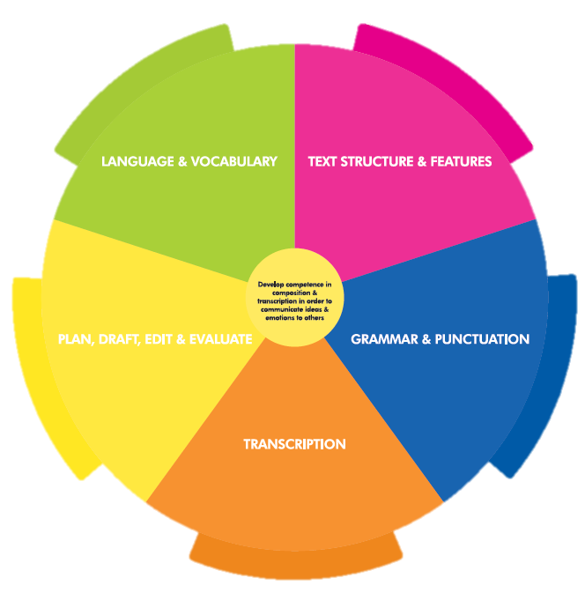

GRAMMAR & PUNCTUATION
I can use relative clauses with relative pronouns who, which, where, whose, that, when
I can indicate possibility using adverbs (maybe, possibly, perhaps, definitely) and modal verbs (shall, might, must, could etc)
I can build cohesions within a paragraph
I can link ideas across paragraphs using adverbials of time, place and number or by varying tense
I can indicate parenthesis using brackets, dashes and commas
I can use commas to clarify meaning and avoid ambiguity
I can use expanded noun phrases for accuracy
I can use the active/passive voice for effect
I can use the perfect form to indicate time/cause
I can use hyphens to avoid ambiguity
I can use colons to introduce a list and mark boundaries between clauses
I can use semi-colons in a longer list and to mark boundaries between clauses
I can punctate bullet points correctly
I can use a wider range of cohesive devices (repetition of word/phrase, adverbials and ellipsis)
I can identify formal/informal structures eg question tags, subjunctive form
LANGUAGE & VOCABULARY
I can use my knowledge of language from stories, plays and poetry to enhance the effectiveness of my writing
I can select appropriate language and vocabulary to reflect my understanding of audience and purpose
I am familiar with the language of writing eg figurative language, imagery, style and effect
I can develop characters, settings and atmosphere using language and vocabulary from reading/books
I can integrate dialogue to advance action and convey character
I can evaluate how authors use language and consider effect on the reader
I can use dictionaries (and thesauruses) to check meaning of new words/language

TEXT STRUCTURE & FEATURES
I can summarise and present familiar stories in my own words
I can summarise main ideas from more than one paragraph using evidence
I can use my knowledge of language and structure gained from stories, plays, poetry and non-fiction in my writing
I can reflect an understanding of audience and purpose though my choice of grammar, vocabulary and structure
In fiction, I can consider how authors develop character and setting
I am familiar with a wide range of books including myths, legends, fairy stories, modern fiction, fiction from literary heritage and books from other cultures
I can evaluate how authors use language and consider effect on the reader
I can use a wide range of devices to build cohesion within and across paragraphs
I can use further organisational and presentational devices to structure text
PLAN, DRAFT, EDIT & EVALUATE
I can use dictionaries to check the spelling and meaning of words
I can identify different audiences and purposes of writing
I can note and develop my initial ideas drawing on my reading
I can select appropriate grammar and punctuation and understand how these can change and enhance meaning
I can use a wide range of cohesive devices within sentences & between ideas/paragraphs
I can use a wider range of organisational devices
I can assess the effectiveness of my own and others’ writing
I can propose changes to grammar, punctuation and vocabulary to enhance meaning/effectiveness
I can choose the appropriate register (formal/informal)

TRANSCRIPTION
I use a further range of prefixes & suffixes
I can spell some words with silent letters
I can continue to distinguish between homophones and other words that are often confused
I can use my knowledge of morphology and etymology as a strategy for spelling
I can use dictionaries to check spelling and meaning od new words (using first 3 letters)
I can use a thesaurus
I can write legibly, fluently and with increasing speed
I can choose the writing implementation best suited to the task

