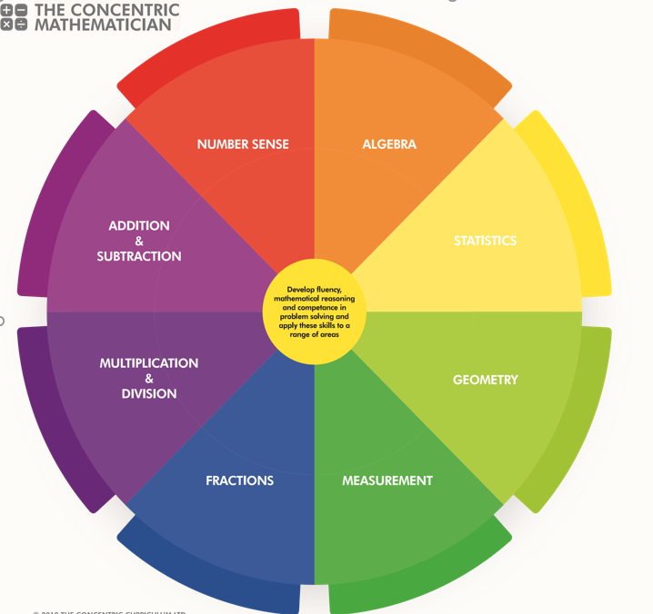
SRPA Mathematician
There are 3 areas underpinning the mathematics curriculum.
Fluency
Pupils develop conceptual understanding and the ability to recall and apply knowledge rapidly and accurately. This is facilitated through varied and frequent practice with increasingly complex problems.
Mathematical reasoning
Pupils learn to follow a line of enquiry and develop an argument, justification or proof using mathematical vocabulary.
Problem solving
Pupils apply their knowledge to a variety of increasingly routine and non-routine problems. They break the problems into a series of simple steps and work systematically to find solutions.

NUMBER SENSE
YEAR 4 PUPIL PASSPORT

I can. count in multiples of 6, 7, 9, 25 and 1,000
…………………………………………………………………………….

I can find 1,000 more or less than a given number…………………………….………………………………….…

I can count backwards through 0 to include negative numbers………………………………………………………………...
I can recognise the place value of each digit in a four-digit number (1,000s, 100s, 10s, and 1s)………………………..

I can round any number to the nearest 10, 100 or 1,000
……………………………………………………………………………

I can order and compare numbers beyond 1000
…………………………………………………………………………….

I can solve number and practical problems that involve all of the above and with increasingly large positive numbers
…………………………………………………………………………....

I can read Roman numerals to 100 (I to C) and know that over time, the numeral system changed to include the concept of 0 and place value
…………………………………………………………………………….

ADDITION AND SUBTRACTION

YEAR 4 PUPIL PASSPORT

I can add and subtract numbers with up to 4 digits using the formal written methods of columnar addition and subtraction where appropriate ………………………….....
I can estimate and use inverse operations to check answers to a calculation solve addition and subtraction two-step problems in contexts, deciding which operations and methods to use and why ……………………………………………….……...
MULTIPLICATION AND DIVISION

YEAR 4 PUPIL PASSPORT

I can recall multiplication and division facts for multiplication tables up to 12 × 12…………………………

I can use place value, known and derived facts to multiply and divide mentally, including: multiplying by 0 and 1; dividing by 1; multiplying together 3 numbers……………….………

I recognise and use factor pairs and commutativity in mental calculations…………………………………………………

I can multiply two-digit and three-digit numbers by a one-digit number using formal written layout…………………

I can solve problems involving multiplying and adding, including using the distributive law to multiply two-digit numbers by 1 digit, integer scaling problems and harder correspondence problems such as n objects are connected to m objects…………………………………………………………………..

FRACTIONS

YEAR 4 PUPIL PASSPORT

I can recognise and show, using diagrams, families of common equivalent fractions ……………..………………….

I can count up and down in hundredths; recognise that hundredths arise when dividing an object by 100 and dividing tenths by 10…………………………………………………………..

I can solve problems involving increasingly harder fractions to calculate quantities, and fractions to divide quantities, including non-unit fractions where the answer is a whole number
………………………………………………………………………….…
I can add and subtract fractions with the same denominator
…………………………………………………………………………….

I can recognise and write decimal equivalents of any number of tenths or hundreds…………………………………

I can recognise and write decimal equivalents to 1/4, 1/2, 3/4……………………………………………………………….………

I can find the effect of dividing a one- or two-digit number by 10 and 100, identifying the value of the digits in the answer as ones, tenths and hundredths………………………………

I can round decimals with 1 decimal place to the nearest whole number…………………………………………………………

I can compare numbers with the same number of decimal places up to 2 decimal places…………………………….....

I can solve simple measure and money problems involving fractions and decimals to 2 decimal places………….…

MEASUREMENT

YEAR 4 PUPIL PASSPORT

I can convert between different units of measure [for example, kilometre to metre; hour to minute]…………….

I can measure and calculate the perimeter of a rectilinear figure (including squares) in centimetres and metres
……………………………………………………………………………

I can find the area of rectilinear shapes by counting squares…..............................................................

I can estimate, compare and calculate different measures, including money in pounds and pence……………………..

I can read, write and convert time between analogue and digital 12- and 24-hour clocks ….………….………………

I can solve problems involving converting from hours to minutes, minutes to seconds, years to months, weeks to days
………………………………………………………………………….…

GEOMETRY

YEAR 4 PUPIL PASSPORT

Shapes
I can compare and classify geometric shapes, including quadrilaterals and triangles, based on their properties and sizes………………………………………………………………………

I can identify acute and obtuse angles and compare and order angles up to 2 right angles by size…………….…

I can identify lines of symmetry in 2-D shapes presented in different orientations……………………………………………….

I can complete a simple symmetric figure with respect to a specific line of symmetry ………………………….……………

Position and Direction:
I can describe positions on a 2-D grid as coordinates in the first quadrant………………………………………….……......…

I can describe movements between positions as translations of a given unit to the left/right and up/down………...

I can plot specified points and draw sides to complete a given polygon…………………………..……………………………

STATISTICS

YEAR 4 PUPIL PASSPORT

I can interpret and present discrete and continuous data using appropriate graphical methods, including bar charts and time graphs solve comparison, sum and difference problems using information presented in bar charts, pictograms, tables and other graphs…………………………..………………………

ALGEBRA

YEAR 4 PUPIL PASSPORT

I can solve addition and subtraction problems involving missing numbers…………………………………………………...

SRPA TIMES TABLE JOURNEY

Hop on board the times table train as you begin your fun- filled journey to become a Times Table Champion.

Don`t forget to pick up a souvenir at each station and remember… practice makes perfect!

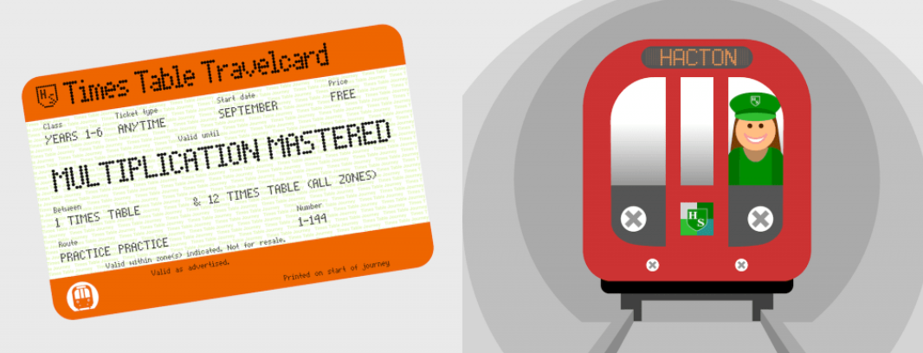
SRPA

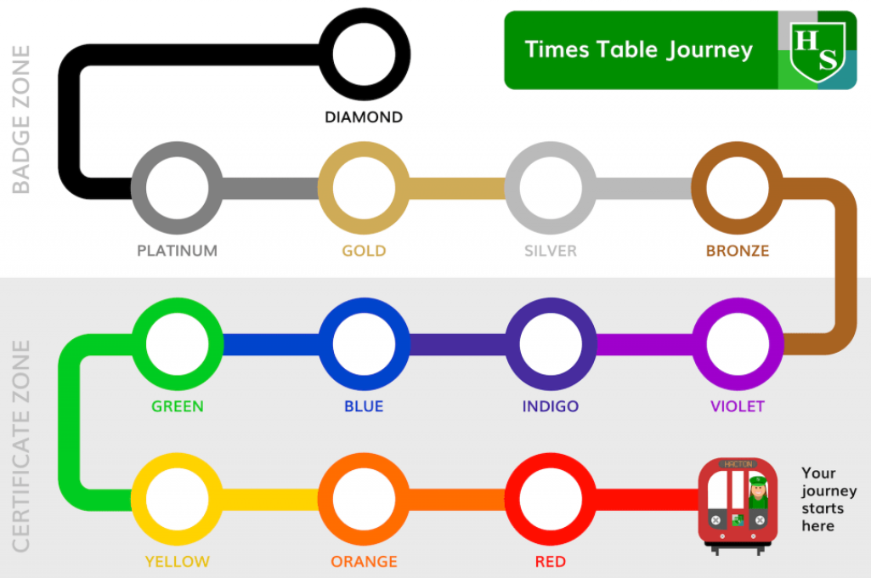
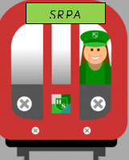
Your journey starts here

SRPA TIMESTABLE JOURNEY

