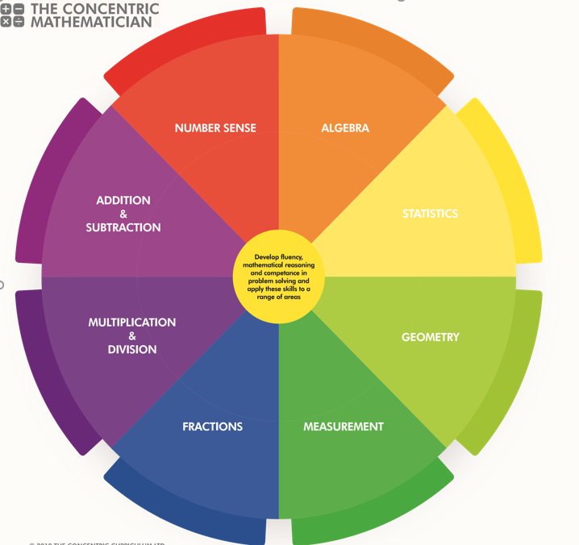
SRPA Mathematician
There are 3 areas underpinning the mathematics curriculum.
Fluency
Pupils develop conceptual understanding and the ability to recall and apply knowledge rapidly and accurately. This is facilitated through varied and frequent practice with increasingly complex problems.
Mathematical reasoning
Pupils learn to follow a line of enquiry and develop an argument, justification or proof using mathematical vocabulary.
Problem solving
Pupils apply their knowledge to a variety of increasingly routine and non-routine problems. They break the problems into a series of simple steps and work systematically to find solutions.

NUMBER SENSE
YEAR 2 PUPIL PASSPORT

I can. count in steps of 2, 3, and 5 from 0, and in 10s from any number, forward and backward…………....

I can recognise the place value of each digit in a two-digit
number (10s, 1s)…………………………….………………………

I can identify, represent and estimate numbers using different representations, including the number line
…………………………………………………………………………….
I can compare and order numbers from 0 up to 100; use
<, > and = sign …………………………………………………...

I can read and write numbers to at least 100 in numerals and in words ……………………………………………………….
I can use place value and number facts to solve problems...............................................................

ADDITION AND SUBTRACTION

YEAR 2 PUPIL PASSPORT

I can solve problems with addition and subtraction using concrete objects and pictorial representations, including those involving numbers, quantities and measures ……………………………………………………………………….....
I can solve problems with addition and subtraction applying their increasing knowledge of mental and written methods………………......……………………………………….....

I can recall and use addition and subtraction facts to 20 fluently, and derive and use related facts up to 100
…………………………………………………………………………..

I can add and subtract numbers using concrete objects, pictorial representations, and mentally, including:
- a two-digit number and 1s
- a two-digit number and 10s
- 2 two-digit numbers
- adding 3 one-digit numbers
………………………………………………………………………..…..
.
I can show that addition of 2 numbers can be done in any order (commutative) and subtraction of 1 number from another………………………………………………………………….

I can recognise and use the inverse relationship between addition and subtraction and use this to check calculations & solve missing number problems………………………………

MULTIPLICATION AND DIVISION

YEAR 2 PUPIL PASSPORT

I can recall and use multiplication and division facts for the 2, 5 and 10 multiplication tables, including recognising odd and even numbers ……………………………………………..…………

I can calculate mathematical statements for multiplication and division within the multiplication tables and write them using the multiplication (×), division (÷) and equals (=) signs
…………………………………………………………………….………

I can show that multiplication of 2 numbers can be done in any order (commutative) and division of 1 number by another cannot…………………………………………………………….…....

I can solve problems involving multiplication and division, using materials, arrays, repeated addition, mental methods, and multiplication and division facts, including problems in contexts
…………………………………………………………………………….

FRACTIONS

YEAR 2 PUPIL PASSPORT

I can recognise, find, name and write fractions 1/3, 1/4, 2/4 and 3/4 of a length, shape, set of objects or quantity
…………………………………………………………………………….

I can write simple fractions, for example 1/2 of 6 = 3 and recognise the equivalence of 2/4 and 1/2………………..

MEASUREMENT

YEAR 2 PUPIL PASSPORT

I can choose and use appropriate standard units to estimate and measure length/height in any direction (m/cm); mass (kg/g); temperature (°C); capacity (litres/ml) to the nearest appropriate unit, using rulers, scales, thermometers and measuring vessels…………………………………………………………………..

I can compare and order lengths, mass, volume/capacity and record the results using >, < and = ………………..

I can recognise and use symbols for pounds (£) and pence (p); combine amounts to make a particular value…....

I can find different combinations of coins that equal the same amounts of money………………………......…………

I can solve simple problems in a practical context involving addition and subtraction of money of the same unit, including giving change….…………………………………………………….
I can compare and sequence intervals of time
………………………………………………………………………….…
I can tell and write the time to five minutes, including quarter past/to the hour and draw the hands on a clock face to show these times…………………………………………………...
I know the number of minutes in an hour and the number of hours in a day…………………………………………….……….

GEOMETRY

YEAR 2 PUPIL PASSPORT

Shapes
I can identify and describe the properties of 2-D shapes, including the number of sides, and line symmetry in a vertical line…………………………………………………………………….….

I can identify and describe the properties of 3-D shapes, including the number of edges, vertices and faces……

I can identify 2-D shapes on the surface of 3-D shapes, [for example, a circle on a cylinder and a triangle on a pyramid]……………………………………………………………….

I can compare and sort common 2-D and 3-D shapes and everyday objects ……………………………………………….....

Position and Direction:
I can order and arrange combinations of mathematical objects in patterns and sequences …………………......…

I can use mathematical vocabulary to describe position, direction and movement, including movement in a straight line and distinguishing between rotation as a turn and in terms of right angles for quarter, half and three-quarter turns (clockwise and anti-clockwise………………………………………….……..

STATISTICS

YEAR 2 PUPIL PASSPORT

I can interpret and construct simple pictograms, tally charts, block diagrams and tables………………………………………

I can ask and answer simple questions by counting the number of objects in each category and sorting the categories by quantity ask-and-answer questions about totalling and comparing categorical data……………………………………

ALGEBRA

YEAR 2 PUPIL PASSPORT

I can solve addition and subtraction problems involving missing numbers…………………………………………………...

SRPA TIMES TABLE JOURNEY

Hop on board the times table train as you begin your fun- filled journey to become a Times Table Champion.

Don`t forget to pick up a souvenir at each station and remember… practice makes perfect!

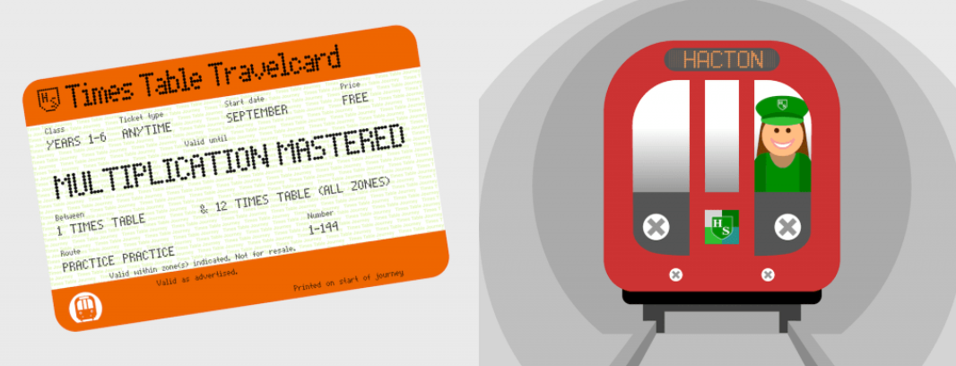
SRPA

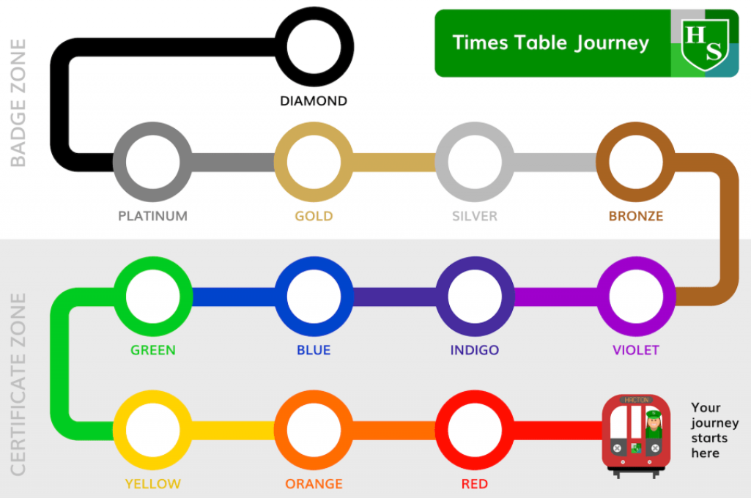
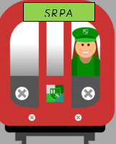
Your journey starts here

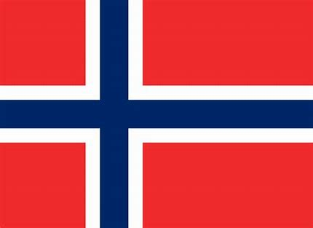

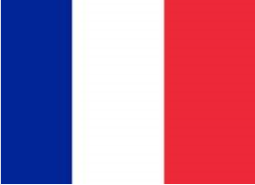

SRPA TIMESTABLE JOURNEY

