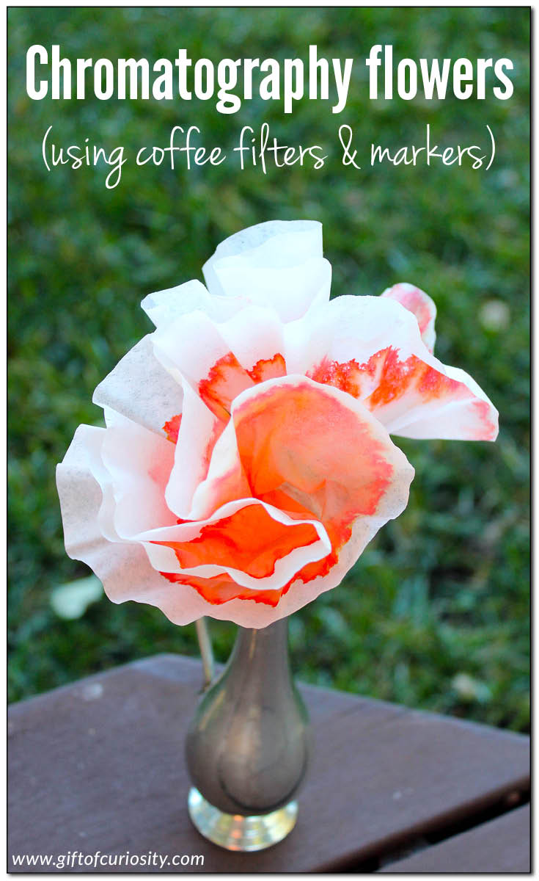
To make chromatography flowers, you need the following materials:
- Coffee filters
- Markers
- Pipe cleaners
- Small container with water

Start by using the markers to colour on the coffee filter. You can experiment with different colours, different designs, drawing close to the centre of the filter, and drawing close to the edge of the coffee filter.
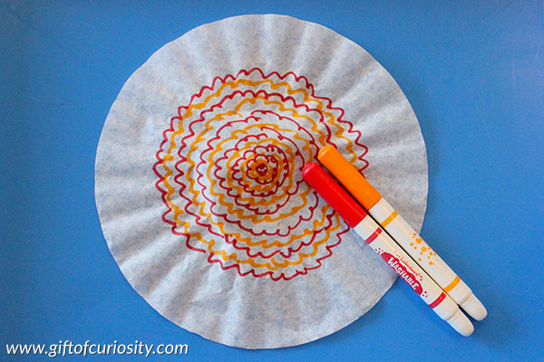
Next, fold your coffee filter in half a few times so it becomes wedge-shaped. This will create a point where the centre of the coffee filter is.
Place the coffee filter into a container with a small amount of water at the bottom.
Note: You do not need to fill the cup all the way with water. This activity works better when only the very bottom of the coffee filter is touching the water.
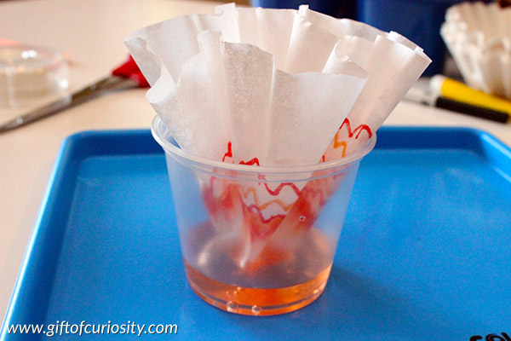
Wait 5 to 10 minutes for the water to seep up through the coffee filter, carrying the marker ink with it and spreading it throughout the coffee filter.
Then unfold your coffee filter and lay flat to dry. I like to place a paper towel on a tray and dry the coffee filter on top.
When the coffee filter is dry, fold it again as you did to put it into the water. Pinch the middle of the filter and wrap a green pipe cleaner around it to make a stem. Fluff out the “petals” as you like.

Extension Questions:
- Why do you think this is happening?
- Can you explain the process behind the chromatography?
- Does it make a difference if you change the variables? (colour of ink/dye used, amount of water, patterns drawn on paper, type of paper you use)

