Read Write Inc Grey Group
Speed Sounds
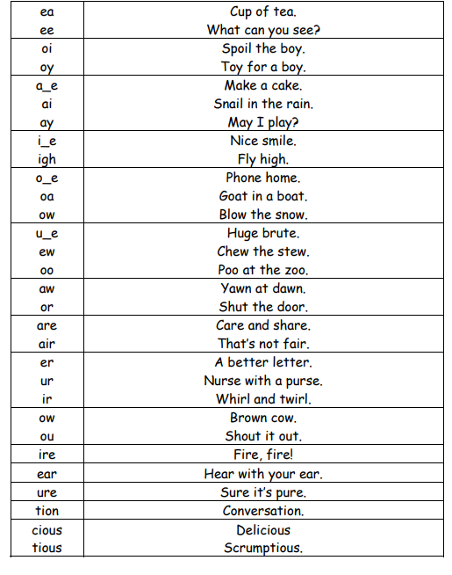

Green words – Grey group
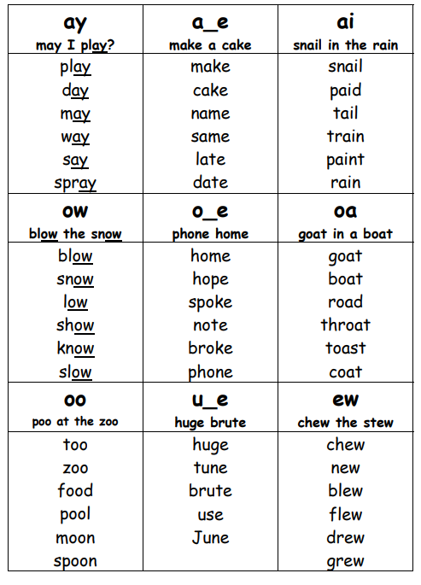
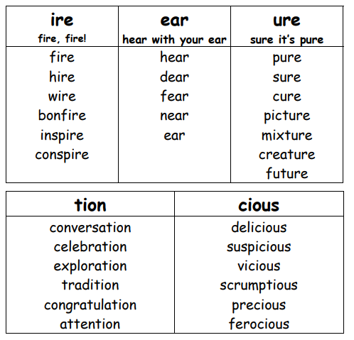

likes | tune | use | June | nose
bite | rude | listen | saw | inside
pile | shadow | month | awful | angry
strange | space | often | square | prepare
scare | climb | chair | beware | remember
better | paper | never | heavy | clean
dirty | fetch | shout | noise | land
coat | doubt | straight | everything | face
afraid | complained | magic | these | pretty
lake | voice | spoke | ugly | owe
promise | knew | forget | blue | boat
white | rules | safe | mean | year
family | knock | dear | ready | Friday
nearly | picture | amazing | largest | behaviour
measure | mixture | parents | adventure | because
station | celebration | invitation | congratulations | nurse
doctor | operation | middle | dinosaur | forest
serious | enormous | delicious | dangerous | obvious
famous | silk | crowd | stupid | person
invisible | horrible | terrible | comfortable

Grey group -Red words
Practise reading these words from sight and practise spelling each word to support independent writing.
should | were | there | because | love | yourself
worse | talk | all | they`re | many | caught
small | would | their | someone | another | walk
above | where | was | anyone | great | brother
watch | come | people | water | do | son
here | do | come | other | above | too
you`re | they | call | want | come | love
wear | some | could | one | through | buy
bought | thought | everyone | father | any | whole
two | who | you | said | was | school
your | what | was | school | mother | are

