Read Write Inc Red Group
Speed Sounds
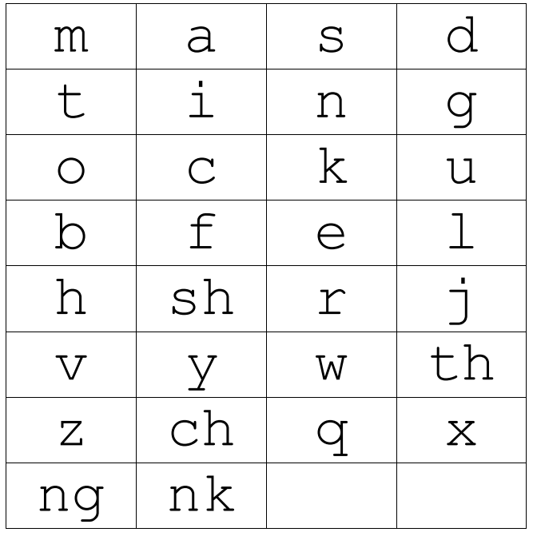

Set 1 Letter Rhymes
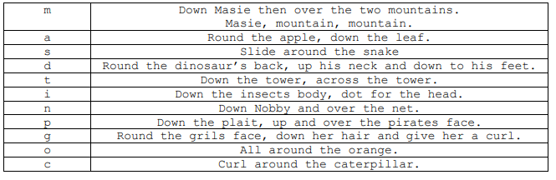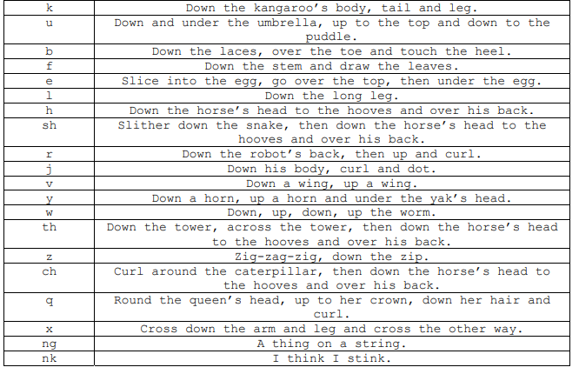

Green words – Red
blob | blip | drop | clip | from
fog | flag | grin | gran | pram
slip | skip | trip | best | bell
well | mess | dress | thing | think
wink | this | zap | chin | chop
chat | quiz | bang | wing | shop
ship | box | fox | fish | sock
sack | kick | drip | test | quick
get | got | an | sit | man
us | am | not

Red words
Practise reading these words from sight. We have provided two of each word card so you can play games like ‘memory’ or ‘snap’.
I | I
no | no
my | my
the | the
of | of
me | me
to | to

