Reading at Stuart Road Primary School
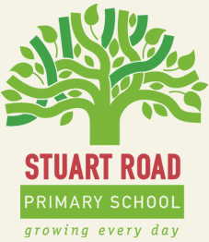
A Guide for Parents and Carers

If your child is currently on the reading scheme at Stuart Road, below is a guide to the books they bring home:

Book Band  KS1 | Reading Age in Years | Book Band  KS2 | Reading Age in Years | Interest Level
Lilac | 4 - 5 | Bronze | 7 - 8 | Y2/3
Pink | 4 - 5 | Silver | 9 – 10 | Y3/4
Red | 4 - 5 | Sapphire | 10 - 11 | Y4/5
Yellow | 5 - 6 | Ruby | 11+ | Y6/7
Blue | 5 - 6 | Please note that the KS2 scheme has been banded according to the interest level and content of each book. Each band is very wide and contains a range of subjects and themes for your child to enjoy.
Green | 5 - 6
Orange | 6 - 7
Turquoise | 6 - 7
Purple | 6 - 7
Gold | 6 - 7
White | 7 - 8
Lime | 7 - 8
Black ~ Bridging Band between KS1 and KS2 | 7+

Here are some tips to help your child/children with their reading:

- Most importantly make it fun! If your child wants to read, they will enjoy the sessions they share with you. Read a range of texts and include things your child wants to read such as comics, magazines or websites. You could even ask them to read and explain the rules of a new game.

- Congratulate children when they try to decode and work out new words. They can use a range of ways to work out new words, including sounding a word out, reading the sentence and deciding which word fits and even using the pictures for clues. Help your child out where needed but don’t jump in too quickly!

- Don’t assume a fluent reader is a ‘good’ reader! We test comprehension to check your child’s reading level which means they need to understand the content of their reading. If (after reading) your child is unable to recall events or describe characters and their actions, then they should reread the text until their understanding is developed.

- Expression, pace and volume are all important too, not just fluency. If your child can’t read a text at a reasonable pace and volume, including expression, then it would show that they are not understanding their reading.

- Be careful to pass off books as ‘too easy’. The level of a text is not decided on the amount of words it contains or the size of the words. Some books have few (or even no) words but the content may be of a higher reading level because of the vocabulary, themes and issues they contain.

- Remember that becoming a fluent and enthusiastic reader isn’t a race! Encouraging your child to rush through the reading scheme will send the wrong message to them. We aren’t just teaching your child to read; we’re encouraging them to be readers for life. Therefore, we will only change your child’s reading book when we are satisfied their book has been read carefully and they clearly understand the content.

- Be a good role model for your child. You may not consider yourself a ‘reader’ but we all read each day for different reasons and purposes. Try these things:

  - Go shopping and give your child a list. Ask them to read the list to you and cross off items as you find them.
  - Look out for road signs/shop names etc when you’re out and about. You could ask them to help plan a journey and read place names to you from maps.
  - Don’t keep your book on your bedside table. Bring it into the front room and make sure your child sees you reading…magazines and papers will do too!
  - Visit an attraction and ask your child to read any signs/information to you.
  - When you eat out, ask your child to read you the menu.

- Encourage your child to ‘lead’ reading sessions; they shouldn’t be chores. Listen to your child’s preferences for reading and take into account their choices when reading together. If your child is a reluctant reader try the following strategies:

  - Suggest they read a line/page and you read a line/page.
  - Ask them to choose their reading material ~ tell them it can be anything but they must read it to you and chat about it after.
  - Don’t read EVERY night and don’t leave it until bedtime each night. Your child will be tired and grumpy!
  - Try a picture book. There are some amazing picture books with themes for older children. You can make up your own story and your child won’t get their ‘reading’ wrong.
  - Listen to an audio story for enjoyment.
  - Read and act out short scripts or funny poems.
  - Reread loved books. It doesn’t have to be a ‘learning’ experience every time you read! However, by revisiting previously read stories you may discover new themes or discuss key issues that were missed before.

- Join the local library. Your child will have a huge range of books to choose from and s/he can take part in summer reading challenges and competitions.

Please take advantage of our open door policy and see Mrs Blake or your class teacher if you have anything you’d like to ask/clarify about your child’s reading.
HAPPY READING

Guide to Reading Terms
comprehension | Understanding of things read. Your child will show this by answering questions about their reading, making predictions about what might happen next, thinking about how a story may have a different ending and expressing their preferences (i.e. which character they liked best etc)
decode | Working out new words by sounding them out/breaking them down. Your child will use their phonic knowledge to break a word into sounds (segment) and recombine (blend) to make meaning.
expression | Using different tones to demonstrate mood and sentiment.
fluent | Reading easily with continuous ‘flow’. Your child may pause over unknown words occasionally but most fluent readers read ahead to ensure flow isn’t broken.
pace | A consistent speed. Pace may change depending on what’s being read e.g. slowly to create suspense, quickly to reflect urgency.
phonic/s | Matching letters and their sounds. This includes single letters and their corresponding sounds and groups of letters that make a single sound e.g. sch.
themes | A lesson or message in a story. The theme of a story could be love, growing up, good versus evil etc.
vocabulary | Words used in a text.

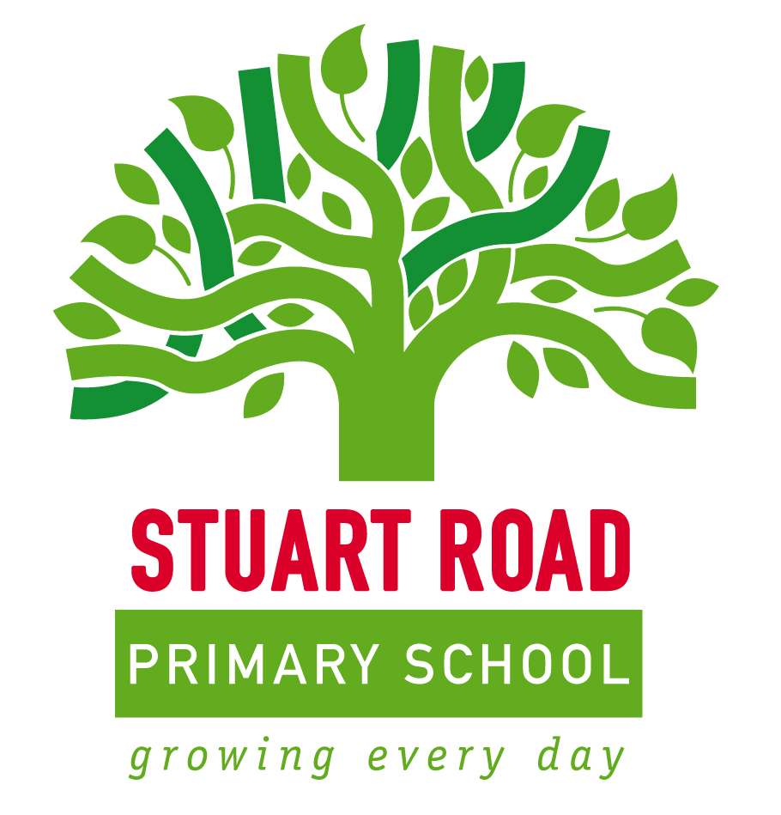
A Guide to Reading at SRPS

