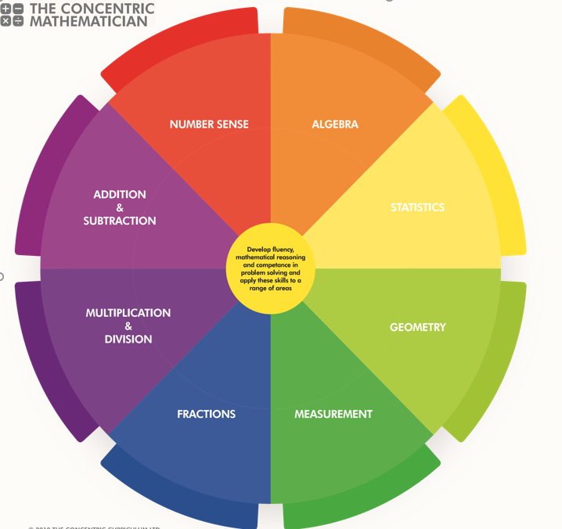
SRPA Mathematician
There are 3 areas underpinning the mathematics curriculum.
Fluency
Pupils develop conceptual understanding and the ability to recall and apply knowledge rapidly and accurately. This is facilitated through varied and frequent practice with increasingly complex problems.
Mathematical reasoning
Pupils learn to follow a line of enquiry and develop an argument, justification or proof using mathematical vocabulary.
Problem solving
Pupils apply their knowledge to a variety of increasingly routine and non-routine problems. They break the problems into a series of simple steps and work systematically to find solutions.

NUMBER SENSE
YEAR 3 PUPIL PASSPORT

I can. count from 0 in multiples of 4, 8, 50 and 100; find 10 or 100 more or less than a given number ………...

I can recognise the place value of each digit in a 3-digit
number (100s, 10s, 1s) …………………………….……………

I can compare and order numbers up to 1,000
…………………………………………………………………………….
I can identify, represent and estimate numbers using different representations………….…………………………………………...

I can read and write numbers up to 1,000 in numerals and in words solve number problems and practical problems involving these ideas………………………………………………

ADDITION AND SUBTRACTION

YEAR 3 PUPIL PASSPORT

I can add and subtract numbers mentally, including:
- a three-digit number and 1s
- a three-digit number and 10s
- a three-digit number and 100s……………………………
I can add and subtract numbers with up to 3 digits, using formal written methods of columnar addition and subtraction………………......………………………………………

I can estimate the answer to a calculation and use inverse operations to check answers solve problems, including missing number problems, using number facts, place value, and more complex addition and subtraction ………………………….

.

MULTIPLICATION AND DIVISION

YEAR 3 PUPIL PASSPORT

I can recall and use multiplication and division facts for the 3, 4 and 8 multiplication tables……………………………

I can write and calculate mathematical statements for multiplication and division using the multiplication tables that they know, including for two-digit numbers times one-digit numbers, using mental and progressing to formal written methods………………………………………………………….……..

I can solve problems, including missing number problems, involving multiplication and division, including positive integer scaling problems and correspondence problems in which n objects are connected to m objects..........................

FRACTIONS

YEAR 3 PUPIL PASSPORT

I can count up and down in tenths; recognise that tenths arise from dividing an object into 10 equal parts and in dividing one-digit numbers or quantities by 10……………………..

I can recognise, find and write fractions of a discrete set of objects: unit fractions and non-unit fractions with small denominators………………………………………………………….

I can recognise and use fractions as numbers: unit fractions and non-unit fractions with small denominators………

I can recognise and show, using diagrams, equivalent fractions with small denominators……………………….…

I can add and subtract fractions with the same denominator within one whole [for example, 5/7+1/7 = 6/7]…..

I can compare and order unit fractions, and fractions with the same denominators solve problems that involve all of the above
……………………………………………………………………………

MEASUREMENT

YEAR 3 PUPIL PASSPORT

I can measure, compare, add and subtract: lengths (m/cm/
mm); mass (kg/g); volume/capacity (l/ml)……………….

I can measure the perimeter of simple 2-D shape
…………………………………………………………………………….

I can add and subtract amounts of money to give change, using both £ and p in practical contexts…………….....

I can tell and write the time from an analogue clock, including using Roman numerals from I to XII, and 12-hour and 24-hour clocks………………………......……………..…

I can estimate and read time with increasing accuracy to the nearest minute; record and compare time in terms of seconds, minutes and hours; use vocabulary such as o’clock, am/pm, morning, afternoon, noon and midnight………………….

I know the number of seconds in a minute and the number of days in each month, year and leap year
………………………………………………………………………….…
I can compare durations of events [for example, to calculate the time taken by particular events or tasks]……….....

GEOMETRY

YEAR 3 PUPIL PASSPORT

I can draw 2-D shapes and make 3-D shapes using modelling materials; recognise 3-D shapes in different orientations and describe them………………………..………

I can recognise angles as a property of shape or a description of a turn………………………………………………

I can identify right angles, recognise that 2 right angles make a half-turn, 3 make three-quarters of a turn and 4 a complete turn; identify whether angles are greater than
or less than a right angle………………………….…………

I can identify horizontal and vertical lines and pairs of perpendicular and parallel lines………….……………….....

STATISTICS

YEAR 3 PUPIL PASSPORT

I can interpret and present data using bar charts, pictograms and tables solve one-step and two-step questions [for example ‘How many more?’ and ‘How many fewer?’]
using information presented in scaled bar charts and pictograms and tables………………………………………………………..……

ALGEBRA

YEAR 3 PUPIL PASSPORT

I can solve addition and subtraction problems involving missing numbers…………………………………………………...

SRPA TIMES TABLE JOURNEY

Hop on board the times table train as you begin your fun- filled journey to become a Times Table Champion.

Don`t forget to pick up a souvenir at each station and remember… practice makes perfect!

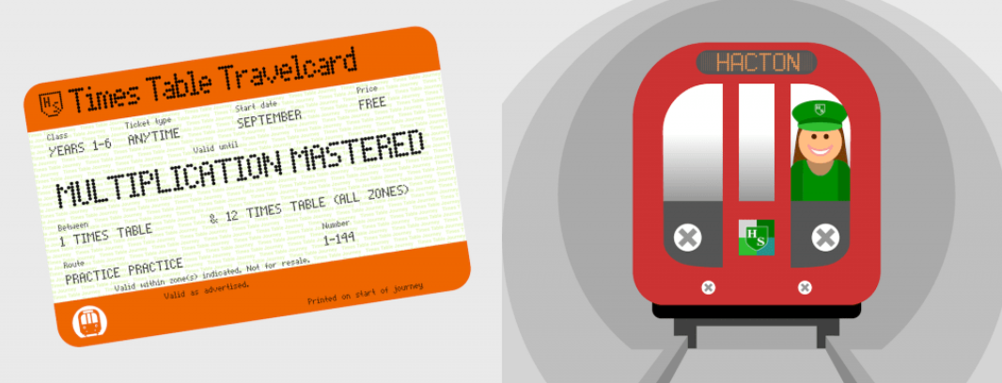
SRPA

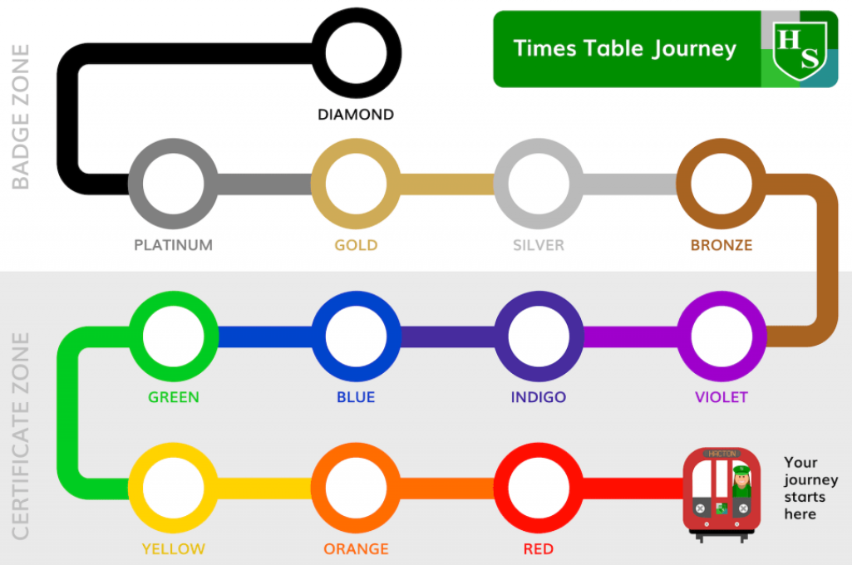
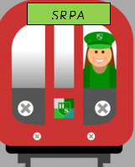
Your journey starts here

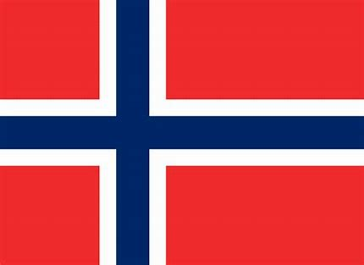

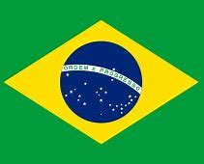

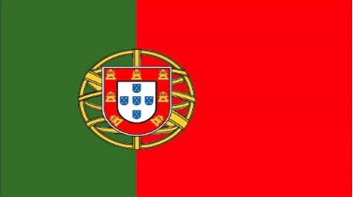

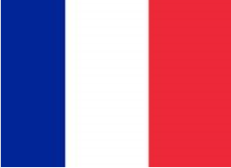

SRPA TIMESTABLE JOURNEY

