Read Write Inc Green Group
Speed Sounds
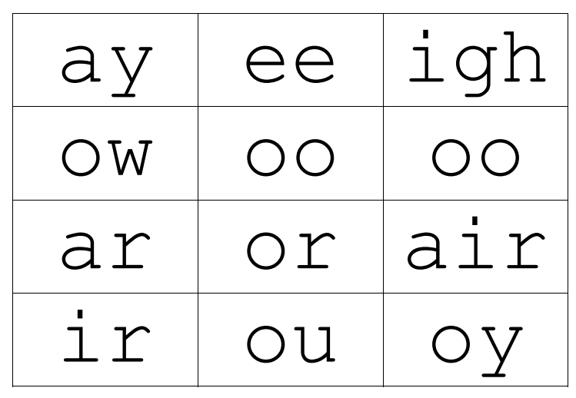

Set 2 Grapheme Rhymes
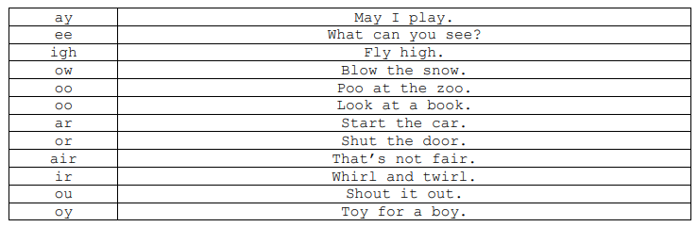

Green words – Green group
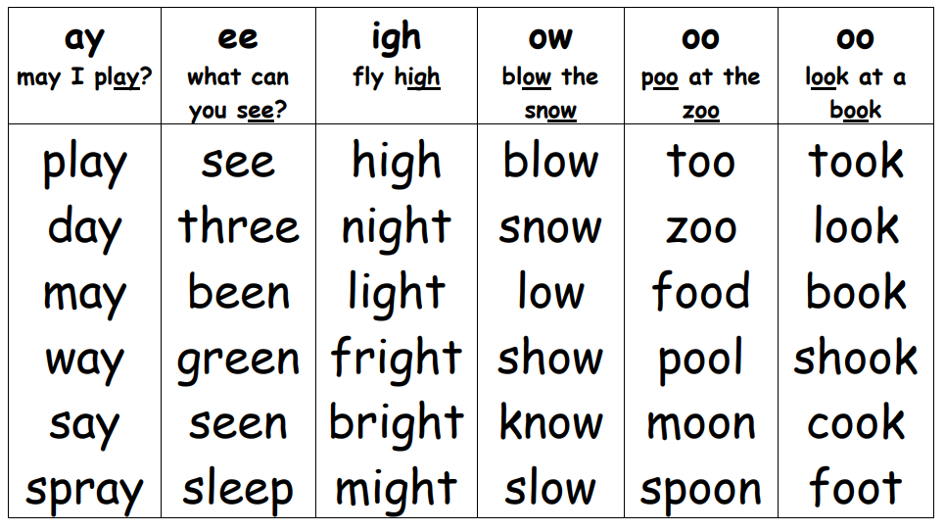

with | fat | thin | this | will
his | leg | had | fish | hat
lot | bad | then | six | mix
ship | box | off | catch | bag
have | but | lots | black | long
pink | red | them | hot | cut
bit | went | milk | bed

Green group- Red words
Practise reading these words from sight. We have provided two of each word card so you can play games like ‘memory’ or ‘snap’.
the | your | I | the | your | I
of | my | be | of | my | be
no | are | do | no | are | do
we | all | they | we | all | they
for | said | he | for | said | he
some | to | is | some | to | is
in | go | me | in | go | me

