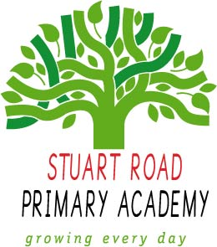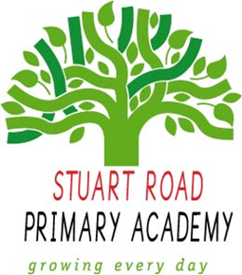 **Exciting Launch!**

STUART ROAD PRIMARY ACADEMY

WRAP AROUND CARE

Starting 8th September 2021

**Breakfast Club** 7.45am to start of school day - £3.50

**Afterschool Club** end of school day to 6.00pm - £9.00

Bookings available via SchoolMoney on 6th September 2021