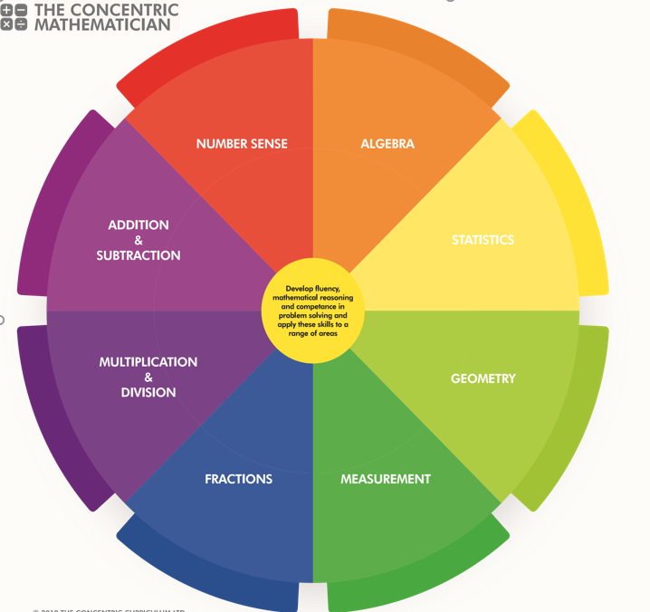
SRPA Mathematician
There are 3 areas underpinning the mathematics curriculum.
Fluency
Pupils develop conceptual understanding and the ability to recall and apply knowledge rapidly and accurately. This is facilitated through varied and frequent practice with increasingly complex problems.
Mathematical reasoning
Pupils learn to follow a line of enquiry and develop an argument, justification or proof using mathematical vocabulary.
Problem solving
Pupils apply their knowledge to a variety of increasingly routine and non-routine problems. They break the problems into a series of simple steps and work systematically to find solutions.

NUMBER SENSE
YEAR 6 PUPIL PASSPORT

I can read, write, order and compare numbers up to 10,000,000 and determine the value of each digit
……………………………………………………………………….……

I can round any whole number to a required degree of accuracy……………………………………………………..…………

I can count backwards through 0 to include negative numbers………………..…………………………………………….…

I can use negative numbers in context, and calculate intervals across 0 solve number and practical problems that involve all of the above…………………………………………

ADDITION AND SUBTRACTION

YEAR 6 PUPIL PASSPORT

I can use knowledge of the order of operations to carry out calculations involving the 4 operations…………………..

I can solve addition and subtraction multi-step problems in contexts, deciding which operations and methods to use and why…………………………………………….…….………………….

I can solve problems involving addition, subtraction, multiplication and division………………………………………

I can use estimation to check answers to calculations and determine, in the context of a problem, an appropriate degree of accuracy……………………………………………..…………………
I can perform mental calculations, including with mixed operations and large numbers…………………………..…….

MULTIPLICATION AND DIVISION

YEAR 6 PUPIL PASSPORT

I can multiply multi-digit numbers up to 4 digits by a two-digit whole number using the formal written method of long multiplication…………………………………………………….……

I can divide numbers up to 4 digits by a two-digit whole number using the formal written method of long division, and interpret remainders as whole number remainders, fractions, or by rounding, as appropriate for the context
…………………………………………………………………………….

I can divide numbers up to 4 digits by a two-digit number using the formal written method of short division where appropriate, interpreting remainders according to the context …………………………………………………………………………....

I can perform mental calculations, including with mixed operations and large numbers identify common factors, common multiples and prime numbers …………………………..……

I can use knowledge of the order of operations to carry out calculations involving the 4 operations ……………………………………………………………………….……

I can solve problems involving addition, subtraction, multiplication and division ……………….………………..…

I can use estimation to check answers to calculations and determine, in the context of a problem, an appropriate degree of accuracy…………………………………………………………….….

FRACTIONS

YEAR 6 PUPIL PASSPORT

I can use common factors to simplify fractions; use common multiples to express fractions in the same denomination………………………………………………………….

I can compare and order fractions, including fractions >1……………………………………………………………………….…
I can add and subtract fractions with different denominators and mixed numbers, using the concept of equivalent fractions………………………………………………

I can multiply simple pairs of proper fractions, writing the answer in its simplest form [for example, 1/4 × ½ =1/8]
………………………………………………………………………….…

I can divide proper fractions by whole numbers [for example, 1/3÷ 2 = 1/6] ……………………………………….…

I can associate a fraction with division and calculate decimal fraction equivalents [for example, 0.375] for a simple fraction [for example, 3/8] …………………………………..

I can identify the value of each digit in numbers given to 3 decimal places and multiply and divide numbers by 10, 100 and 1,000 giving answers up to 3 decimal places………….

I can multiply one-digit numbers with up to 2 decimal places by whole numbers ……………………………………….……….

I can use written division methods in cases where the answer has up to 2 decimal places………………………..

I can solve problems which require answers to be rounded to specified degrees of accuracy recall and use equivalences between simple fractions, decimals and percentages, including in different contexts ……………………………………………..……

Ration and proportion

I can solve problems involving the relative sizes of 2 quantities where missing values can be found by using integer multiplication and division facts……………………………..

I can solve problems involving the calculation of percentages [for example, of measures and such as 15% of 360] and the use of percentages for comparison
……………………………………………………………………….……

I can solve problems involving similar shapes where the scale factor is known or can be found
…………………………………………………………………………....

MEASUREMENT

YEAR 6 PUPIL PASSPORT

I can solve problems involving the calculation and conversion of units of measure, using decimal notation up to 3 decimal places where appropriate………………….…………

I can use, read, write and convert between standard units, converting measurements of length, mass, volume and time from a smaller unit of measure to a larger unit, and vice versa, using decimal notation to up to 3 decimal places
…………………………………………………………………………….

I can convert between miles and kilometres
…………………………………………………………………………….

I can recognise that shapes with the same areas can have different perimeters and vice versa…………….…………….

I can recognise when it is possible to use formulae for area and volume of shapes……………………………………….…..

I can calculate the area of parallelograms and triangles
……………………………………….……………………………………

I can calculate, estimate and compare volume of cubes and cuboids using standard units, including cubic centimetres (cm³) and cubic metres (m³), and extending to other units [for example, mm³ and km³]…………………………………………………………

GEOMETRY

YEAR 6 PUPIL PASSPORT

Shapes
I can draw 2-D shapes using given dimensions and angles..................................................................

I recognise, describe and build simple 3-D shapes, including making nets………………………………………..……………….…

I can compare and classify geometric shapes based on their properties and sizes and find unknown angles in any triangles, quadrilaterals, and regular polygons………………………

I can illustrate and name parts of circles, including radius, diameter and circumference and know that the diameter is twice the radius………………………………………………………………

I can recognise angles where they meet at a point, are on a straight line, or are vertically opposite, and find missing angles…………………………………………………………….....…

Position and Direction:

I can identify, describe and represent the position of a shape following a reflection or translation, using the appropriate language, and know that the shape has not changed
…………………………………………………………………………….

I can describe positions on the full coordinate grid (all 4 quadrants) draw and translate simple shapes on the coordinate plane, and reflect them in the axes……………………….…

STATISTICS

YEAR 6 PUPIL PASSPORT

I can interpret and construct pie charts and line graphs and use these to solve problems…………….………………………

I can calculate and interpret the mean as an average
…………………………………………………………………………….
ALGEBRA

YEAR 6 PUPIL PASSPORT

I can use simple formulae
…………………………………………………………………………….

I can generate and describe linear number sequences
…………………………………………………………………………….

I can express missing number problems algebraically
………………………………………………………………………….…

I can find pairs of numbers that satisfy an equation with 2 unknowns………………………………………………………………

I can enumerate possibilities of combinations of 2 variables
………………………………………….…………………………………

SRPA TIMES TABLE JOURNEY

Hop on board the times table train as you begin your fun- filled journey to become a Times Table Champion.

Don`t forget to pick up a souvenir at each station and remember… practice makes perfect!

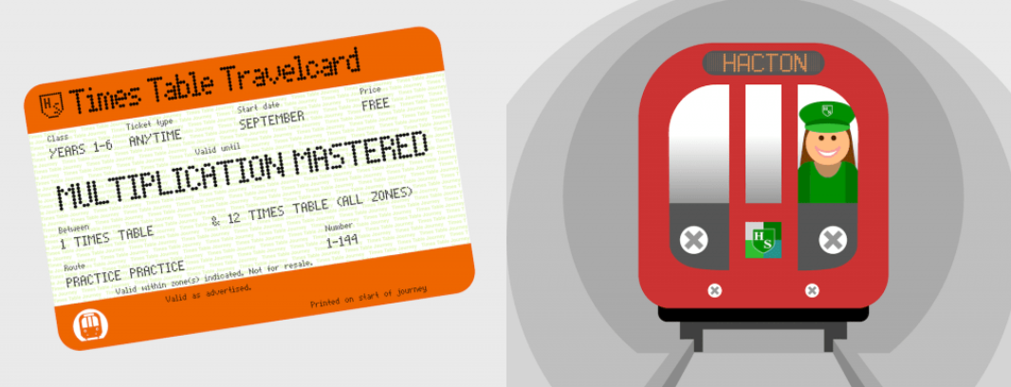
SRPA

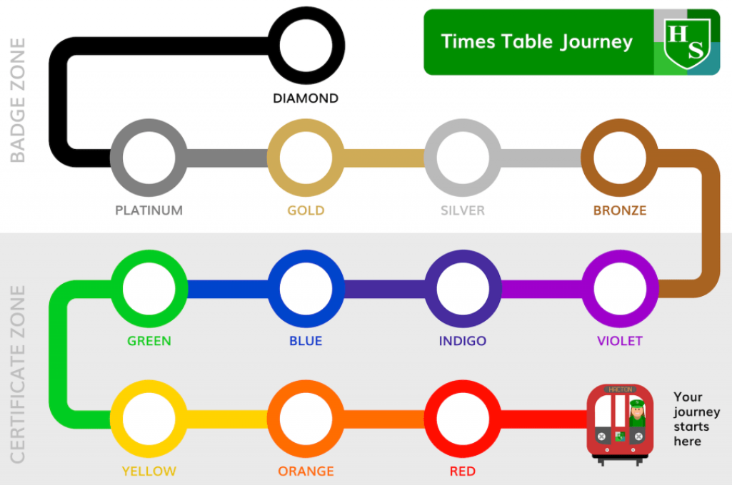
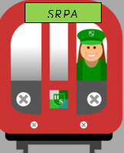
Your journey starts here

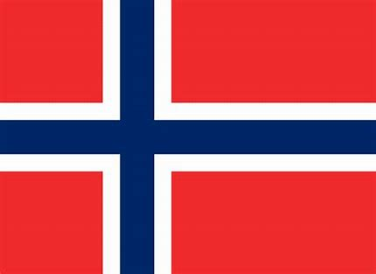

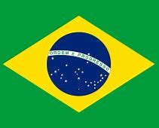

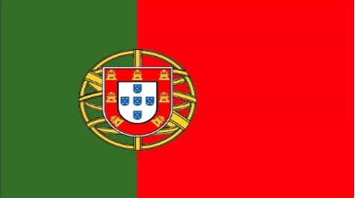

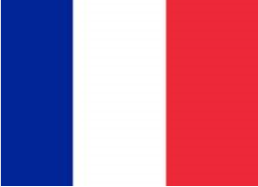

SRPA TIMESTABLE JOURNEY

