**Read Write Inc Blue Group**

**Speed Sounds**

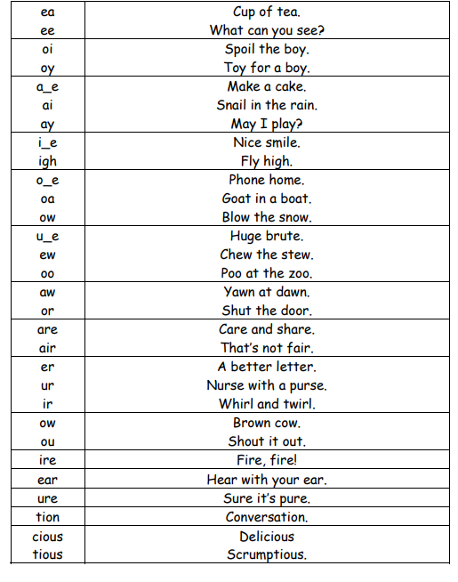

**Green words – Blue group**

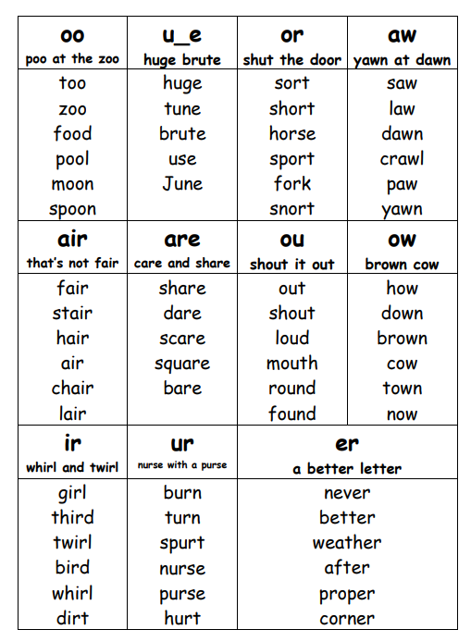

|  |  |  |  |  |
| --- | --- | --- | --- | --- |
| until | beginning | apart | between | indeed |
| agreed | horse | animal | morning | before |
| across | chance | importantly | fairy | unfair |
| children | stuck | almost | always | choose |
| upset | fantastic | thirsty | garden | ground |
| loud | stairs | found | sound | poor |
| hard | enjoy | marry | together | name |
| made | why | take | mistake | same |
| place | instead | please | really | least |
| leave | make | five | quite | time |
| life | smile | hide | while | those |
| suddenly | alone | hole | wrote | home |

**Blue group -Red words**

Practise reading these words from sight and practise spelling each word to support independent writing.

|  |  |  |  |  |  |
| --- | --- | --- | --- | --- | --- |
| does | were | all | bother | one | said |
| any | brother | mother | other | two | one |
| are | her | there | could | where | they |
| would | want | because | their | watch | some |
| why | water | anyone | over | your | who |
| does | school | son | through | once | here |