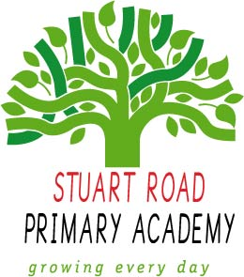
Stuart Road Primary Academy
Home Learning
Year 5 Autumn 2019
Theme: Once Upon a Time
To get the most out of your home learning you must:
Complete the ‘daily tasks’ every day.
Select another task of your choice to complete each week.
We look forward to sharing your completed work in school.
Creative Writing
Write a story based on an existing traditional tale changing elements of character and plot – try inverting the characters or plot.
Write a job advert for someone to capture the wolf. What skills will you be looking for? What type of personality will be successful? Who will they need references from? Will they need to provide any of their own equipment?
News of Red Riding Hood’s escape is spreading through Fairy Land. Write a news report on the events with quotes from the key characters. Think of a snappy headline.
Theme
Design a poster to display in a room of your home to encrouage the members of your family to recycle.
Using any materials of your choice (e.g paint, tissue paper) create a forest scene from a traditional tale.
Using resources that you have at home (e.g empty cereal packets) design and make your own mechanical book.
Draw a labelled picture of yourself appearing as a villain in a traditional tale.
Research the Grimm Brothers and create a poster to share what you have learned.
Visit
Visit a library and use books to research various traditional tales.
Visit the cinema or theatre to watch a version of a traditional tale.
Recreate your own traditional tale with your family and film it.
Visit a bookshop and explore different mechanical books.

Maths
Write word problems relating to famous story characters.
Create an illustration for a traditional tale using various shapes and label the shapes properties.
Design a ‘crack the code’ using your place value knowledge to reveal a repeated phrase from a traditional tale.

Daily tasks
- Read your reading book.
- Practise your handwriting.
- Practise your timestables.
- Practise your spellings.

