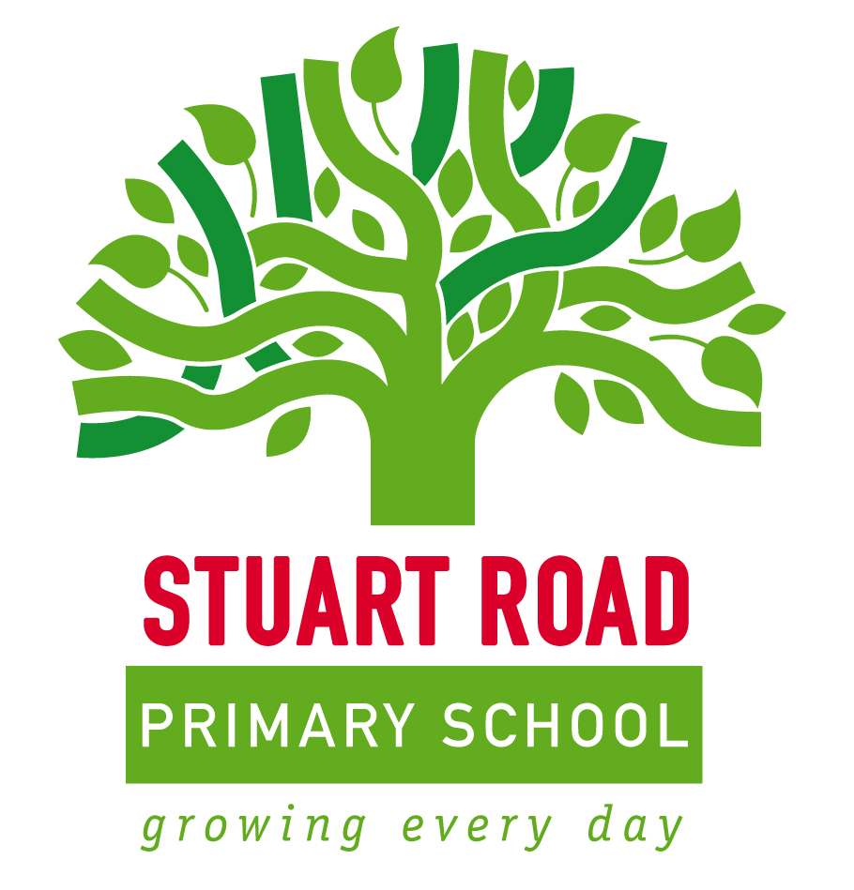
Handwriting at SRPS

Dear Parents and Carers
After a lot of careful thought and research, we have decided to adopt a cursive style of handwriting across the school. Here are the reasons behind this change:
- It is recommended by the British Dyslexia Association because:
- By making each letter in one movement, children’s hands develop a ‘physical memory’ of it, making it easier to produce the correct shape;
- Because letters and words flow from left to right, children are less likely to reverse letters which are typically difficult (like b/d or p/q);
- There is a clearer distinction between capital letters and lower case;
- The continuous flow of writing ultimately improves speed and spelling.
(Please note that these reasons do not only benefit dyslexic children; they are helpful to all pupils.)
- The National Curriculum requires that all children should be joining fluently by the end of Year 2, and the interim assessment arrangements say that children cannot be ‘exceeding’ (Years 2 – 6) unless they are joining fluently.

- Children had been learning to print within the EYFS/Year 1 and then having to relearn how to join in Year 2. Handwriting experts claim this is akin to learning “two different languages”. To begin learning the precursive style then allows children to begin joining naturally once they have some fluency and confidence.
We will be offering some parent workshops in September so that you can come along and have a go at learning the handwriting style yourselves. In the meantime, please find a diagram overleaf which shows the letter formation of both the precursive and cursive style. Please note that if your child already has an established, joined style we will not ask them to ‘relearn’ to join in the cursive style. If you have any questions about handwriting please get in touch with Mrs Blake.
Many thanks, The Stuart Road Staff.

