Read Write Inc Pink Group
Speed Sounds
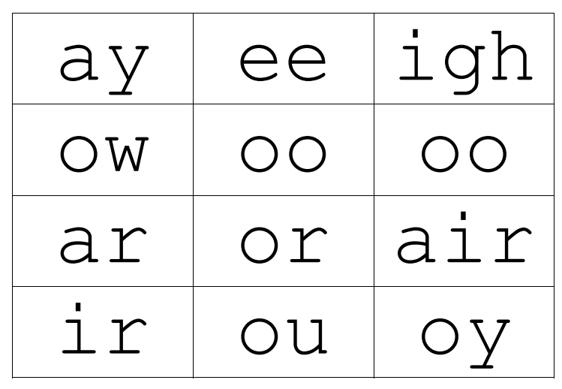

Set 2 Grapheme Rhymes
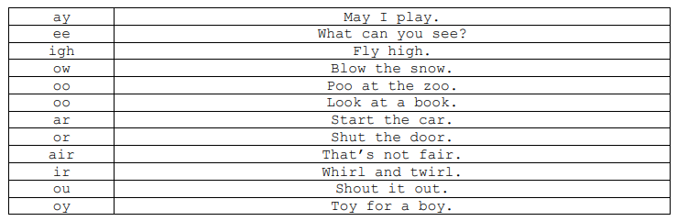

Green words – Pink group
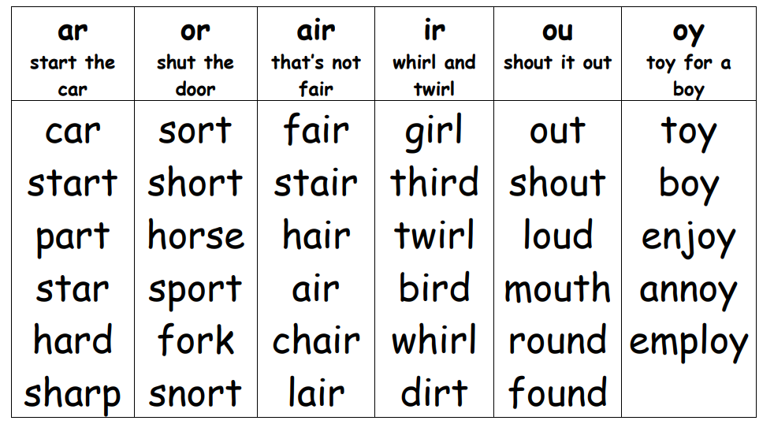

from | well | such | rest | pet
smell | must | if | sun | soft
hand | rock | ask | cap | vest
sock | along | drink | quick | way
say | stay | day | yet | green
keep | when | three | just | night
right | might | play | feel | follow
street | last | snow | throw | grow
own | sleep | food | cool

Pink group- Red words
Practise reading these words from sight. We have provided two of each word card so you can play games like ‘memory’ or ‘snap’.
the | your | I | the | your | I
of | my | be | of | my | be
no | are | do | no | are | do
we | all | they | we | all | they
for | said | he | for | said | he
some | to | is | some | to | is
in | go | me | in | go | me

