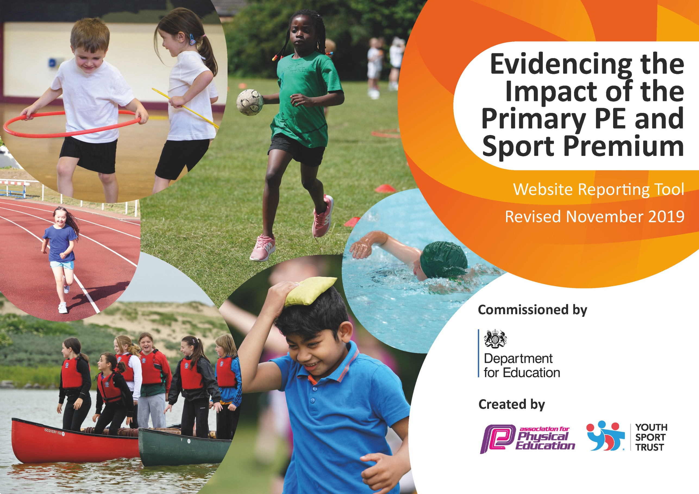
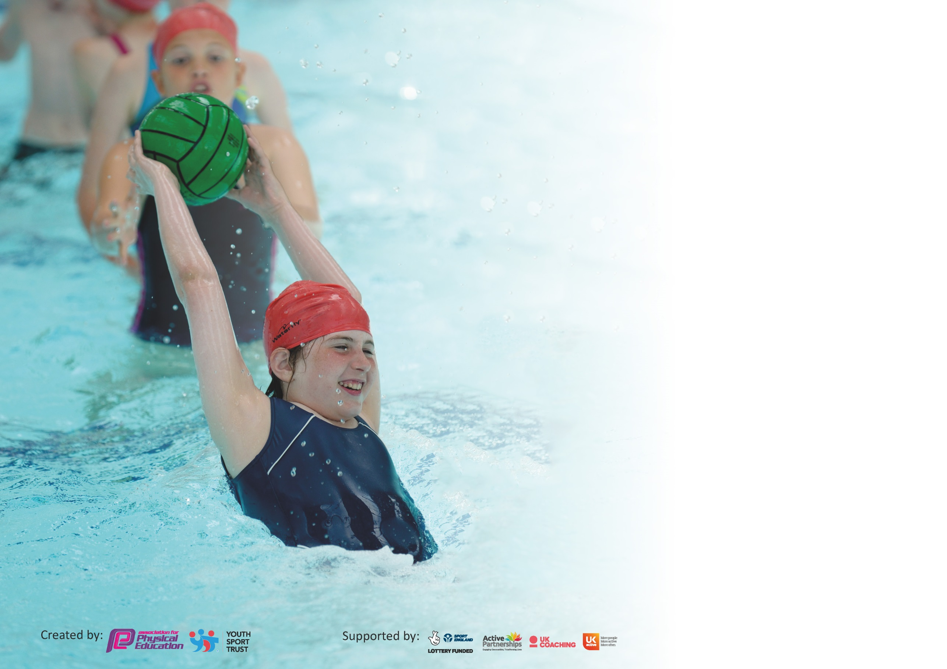

It is important that your grant is used effectively and based on school need. The Education Inspection Framework (Ofsted 2019 p64) makes clear there will be a focus on ‘whether leaders and those responsible for governors all understand their respective roles and perform these in a way that enhances the effectiveness of the school’.

Under the Quality of Education criteria (p41) inspectors consider the extent to which schools can articulate their curriculum (INTENT), construct their curriculum (IMPLEMENTATION) and demonstrate the outcomes which result (IMPACT).

To assist schools with common transferable language this template has been developed to utilise the same three headings which should make your plans easily transferable between working documents.

Schools must use the funding to make additional and sustainable improvements to the quality of Physical Education, School Sport and Physical Activity (PESSPA) they offer. This means that you should
use the Primary PE and Sport Premium to:

- Develop or add to the PESSPA activities that your school already offer
- Build capacity and capability within the school to ensure that improvements made now will benefit pupils joining the school in future years

Please visit gov.uk for the revised DfE guidance including the 5 key indicators across which schools should demonstrate an improvement. This document will help you to review your provision and to report your spend. DfE encourages schools to use this template as an effective way of meeting the reporting requirements of the Primary PE and Sport Premium.

We recommend you start by reflecting on the impact of current provision and reviewing the previous spend.

Schools are required to publish details of how they spend this funding as well as on the impact it has on pupils’ PE and sport participation and attainment by the end of the summer term or by 31st July 2020 at the latest.

We recommend regularly updating the table and publishing it on your website throughout the year. This evidences your ongoing self-evaluation of how you are using the funding to secure maximum, sustainable impact. Final copy must be posted on your website by the end of the academic year and no later than the 31st July 2020. To see an example of how to complete the table please click HERE.

Support for review and reflection - considering the 5 key indicators from DfE, what development needs are a priority for your setting and your pupils now and why? Use the space below to reflect on previous spend and key achievements and areas for development.

Key achievements to date until July 2019: | Areas for further improvement and baseline evidence of need:
- Achieved Silver Award with School Games Mark 2019.  - Development of high quality CPD for all teaching staff in PE lessons.  - School football team achieved 6th in Plymouth Primary Schools football League- team equipped with sponsored kit supplied (cost supplemented) by a local business.  - Participated in Level 3 competition for Rounders event at Devon School Games and Athletics at Brickfields with other Plymouth Schools.  - Participated in Plymouth Primary Schools Athletics meet at Brickfields- 2 children placed in finals & boys relay team competed in finals.  - Attended Indoor Athletics events for LKS2 and UKS2.  - Participated in local Quadkids events.  - Participated in Netball Tournament.  - Established Netball & Tag Rugby festival with sister school within the REACH South MAT. | - Maintain Silver Award with School Games Mark- look into achieving Gold with increasing range of competitive sport and provision of clubs for the least active.  - Development of after school club (sports based) clubs.  - Provision of a Change for Life Club (targeting inactive children)  - Development of a positive attitude to physical activity at lunchtimes & sports leaders- CPD to be provided by a sports coach for Meal Time Assistants (MTAs).  - Increase range of sports festivals with sister school within REACH South MAT.

Meeting national curriculum requirements for swimming and water safety.
What percentage of your current Year 6 cohort swim competently, confidently and proficiently over a distance of at least 25 metres?  N.B. Even though your pupils may swim in another year please report on their attainment on leaving  primary school at the end of the summer term 2020. | 74%
What percentage of your current Year 6 cohort use a range of strokes effectively [for example, front crawl, backstroke and breaststroke]? | 74%
What percentage of your current Year 6 cohort perform safe self-rescue in different water-based situations? | 96%
Schools can choose to use the Primary PE and Sport Premium to provide additional provision for swimming but this must be for activity over and above the national curriculum requirements. Have you used it in this way? | Yes/No

Action Plan and Budget Tracking
Capture your intended annual spend against the 5 key indicators. Clarify the success criteria and evidence of impact that you intend to measure to evaluate for pupils today and for the future.

Academic Year: 2018/19 | Total fund allocated: £17740 | Date Updated: 04-12-19
Key indicator 1: The engagement of all pupils in regular physical activity – Chief Medical Officer guidelines recommend that primary school pupils undertake at least 30 minutes of physical activity a day in school |  |  |  | Percentage of total allocation:
 |  |  |  | 11%
Intent | Implementation |  | Impact
Your school focus should be clear what you want the pupils to know and be able to do and about  what they need to learn and to  consolidate through practice: | Make sure your actions to achieve are linked to your intentions: | Funding allocated: | Evidence of impact: what do pupils now know and what can they now do? What has changed?: | Sustainability and suggested next steps:
Increase quality of provision of PE and sport through purchase and maintenance of PE equipment in school to be used during curricular time and in extra curricular PE.  New PE experiences for whole year groups | Purchase of basketball posts and goal post for football in main playground.  Purchase of additional PE equipment to replace old equipment.  Purchase of portable sound system & upgrade of existing portable sound system to support dance activities to be utilised during curriculum PE and break times.  Children to utilise equipment during curriculum and extra curriculum times for intended sports.  Book Y4 onto Moorland Walk at Burrator via PSSP website  Book Y5 onto Bell boating activity day at Oreston Quay via PSSP.  Book Y6 onto mountain biking and orienteering day at Saltram House via PSSP website.  Transport to sporting events. | £1,501.32  £423.80  None - part of PSSP subscription  £100 | Raised level of interest in basketball/ netball and football during extra-curricular times as well as through PE sessions.  Increased engagement of physical activity to music.  Participation in new activities and making links with external PE providers. | Continue maintaining good quality PE equipment whilst raising the profile of sport & physical activity.  Make bookings onto outdoor education opportunities via PSSP website for 2019-2020.
Key indicator 2: The profile of PESSPA being raised across the school as a tool for whole school improvement |  |  |  | Percentage of total allocation:
 |  |  |  | 20%
Intent | Implementation |  | Impact
Your school focus should be clear what you want the pupils to know and be able to do and about  what they need to learn and to  consolidate through practice: | Make sure your actions to achieve are linked to your intentions: | Funding allocated: | Evidence of impact: what do pupils now know and what can they now do? What has changed?: | Sustainability and suggested next steps:
Continued membership into the Plymouth Schools Sports Partnership (PSSP) - gaining access to a variety of Level 2 & 3 competitions.  Organise and engage in a netball/ tag rugby festival with sister school (High Street Academy) within REACH South MAT.  Raise profile of our school at competitions.  Provide parents with information about additional opportunities for children- accessing sport outside of school.  Celebrate sporting achievements in school. | Application and participation of a variety of Level 2/3 competitions.  Participate in Level 2 competition with sister school within REACH South MAT.  Purchase of school vests for raising the profile of competitive school sport at Level 2/3 competitions.  Use school noticeboard in playground area, school website leaflets and social media to publicise additional opportunities.  Celebrate children’s sporting achievements through whole school assemblies & publicising external clubs. | £3500  None  £294  None  None | Children experiencing competition against children other than peers in own school.  Raised profile and interest in netball and tag rugby.  Increased status of sport within our school through provision of a team kit.  Children accessing clubs outside of school. | Continued membership to PSSP. Continue accessing competitions on offer from PSSP.  Develop opportunities for competition against High Street Academy.  Maintenance of school kit with purchase of additional vests.  Continue maintaining links with outside sporting organisations- to further involve children in more sports provision.

Key indicator 3: Increased confidence, knowledge and skills of all staff in teaching PE and sport |  |  |  | Percentage of total allocation:
 |  |  |  | 62%
Intent | Implementation |  | Impact
Your school focus should be clear | Make sure your actions to | Funding | Evidence of impact: what do | Sustainability and suggested
what you want the pupils to know | achieve are linked to your | allocated: | pupils now know and what | next steps:
and be able to do and about | intentions: |  | can they now do? What has
what they need to learn and to |  |  | changed?:
consolidate through practice:
Improved quality of PE sessions through CPD for teachers- engaging all children in physical activity; giving children a positive mindset with physical activity and enhancing physical and mental well-being. | CPD for all staff in delivery of high quality PE sessions. | £10,631.80 | Increased confidence in staff delivery of PE sessions. Children engaged in highly quality PE sessions- profile of PE raised giving children a positive attitude to physical activity. | Staff to continue delivery of quality PE sessions.  CPD to be provided via the PSSP for teachers requiring additional support.  Extend CPD to Meal Time Assistants to support raised physical activities at break times.
Collection of photographic/video evidence showing good quality PE lessons being delivered, and collected on Assessment Wheel app (PE evidencing tool).  Evidence used to support School Games Mark 2020. | Purchase of an iPad to be shared amongst staff, to collect data for PE.  Evidence used to support School Games Mark application in 2019-2020. | £340.83 - iPad purchase & protective case  £35 - purchase of Assessment Wheel subscription. | Correlation of evidence to support delivery of PE in school. | Staff to collect evidence of good quality PE during curriculum time and competitions.
Key indicator 4: Broader experience of a range of sports and activities offered to all pupils |  |  |  | Percentage of total allocation:
 |  |  |  | 5%
Intent | Implementation |  | Impact
Your school focus should be clear | Make sure your actions to | Funding | Evidence of impact: what do | Sustainability and suggested
what you want the pupils to know | achieve are linked to your | allocated: | pupils now know and what | next steps:
and be able to do and about | intentions: |  | can they now do? What has
what they need to learn and to |  |  | changed?:
consolidate through practice:
Additional achievements:  Provision of high quality PE based after school clubs- raising the profile of sport through after school clubs and engagement in physical activity. | Provision of PE based after school clubs three afternoons per week. | £825 | Uptake of places in PE based after school clubs. Increasing levels of physical activity. | Increase provision of PE based after school clubs- increase to 5 days per week.  Access additional resources such as dance mats, Frisbee golf, archery and indoor curling kits for after school clubs.

Key indicator 5: Increased participation in competitive sport |  |  |  | Percentage of total allocation:
 |  |  |  | 0.3%
Intent | Implementation |  | Impact
Your school focus should be clear | Make sure your actions to | Funding | Evidence of impact: what do | Sustainability and suggested
what you want the pupils to know | achieve are linked to your | allocated: | pupils now know and what | next steps:
and be able to do and about | intentions: |  | can they now do? What has
what they need to learn and to |  |  | changed?:
consolidate through practice:
Membership and participation in Plymouth Primary Schools’ Football League 2018-2019 season. | Participation in all games within the league. | £55 (membership fee) | Attendance of all games- squad achieving 6th position in the league | Continued participation in the league for the season 2019-2020.
Participation in Level 2/3 competitions provided by Plymouth Schools Sports Partnership (PSSP). | Attendance of Level 2/3 competitions | None | Raised profile of sports through attendance and participation of Level 2/3 competitions. | Continued membership of the PSSP and participation

