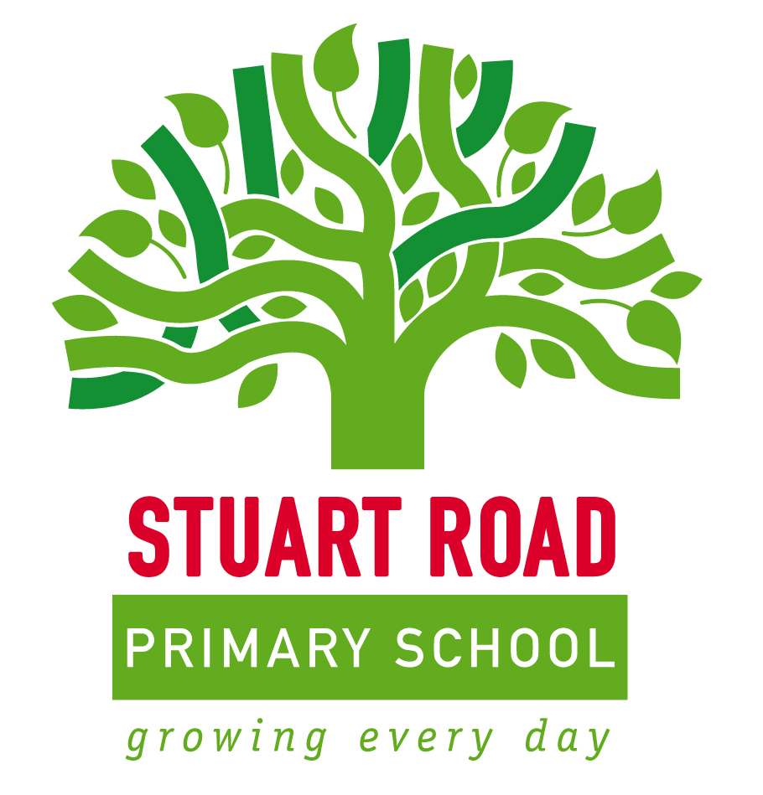

SEN Information Report 2019/2020

Stuart Road Primary School Special Educational Needs and Disability Report
The following report outlines Stuart Road Primary School’s approach to identifying and supporting children that have special educational needs. We are dedicated to providing appropriate and high quality provision to all children who attend our school. We believe all children have the right to a broad and balanced curriculum- both academic and social, which is fully accessible and engaging to them. We strive to ensure all children have the tools needed to access and enjoy their education and experience success.
We are committed to providing an inclusive environment where children feel safe and valued. We respond to the needs of the children within our care, working hard to build a sense of community and belonging where we value the child as an individual. We believe in providing equal opportunities to all children within our school, and pay particular attention to provision and achievement within specified groups of learners such as:
Children with English as an Additional Language (EAL)
Children identified as having Special Educational Needs (SEN)
‘A child or young person has SEN (Special Educational Needs) if they have a learning difficulty or disability which calls for special educational provision to be made for them.
A child of compulsory school age or a young person has a learning difficulty or disability if they:
- Have a significantly greater difficulty in learning than the majority of other children of the same age; or
- Have a disability which prevents or hinders them from making use of the educational facilities of a kind generally provided for others of the same age in mainstream schools or mainstream post- 16 institutions.’

SEND Code of Practice 2014 p.15-16
Children with a disability
Children who are looked after by the local authority (LAC)
Girls and Boys

What is Special Educational Needs?

The four areas of need that the Code of Practice identifies are:
- Communication and Interaction
- Cognition and Learning
- Social, Mental and Emotional Health
- Sensory and/or Physical Needs

Our approach to SEN
- As a staff we ensure that the SEN and Disability Act and relevant Codes of Practice and guidance are implemented effectively across the school.
- We value the views of Parents/Carers and the vital role they play in supporting their child’s education.
- We value the views of the child and ensure that they are listened to and acted upon.
- We aim to provide an inclusive environment where all children feel confident and secure.
- We continually monitor the progress of all children and identify needs as they arise to ensure that support is in place as early as possible.
- We provide both individual and group targeted support and interventions for pupils recognised as having SEN.
- We aim to support each child in becoming confident, capable independent learners.
- We involve children in reviewing their progress so that their voice is clearly recognised in any decisions made.

Who is responsible for SEN and Inclusion within the school and how do I contact them?
Our SENCo is Mrs Louise Scott
She can be contacted through the school office on 01752 567668
Email: louise.scott@reachsouth.org

How is SEN provision coordinated and monitored?
The progress and attainment of children within our school is reviewed regularly, with pupil progress meetings held termly. These meetings are led by the Senior Leadership Team and aim to monitor progress and provision. At these times support may be changed in order to meet identified needs.
Identifying Needs and Monitoring Arrangements
- All children have access to quality first teaching which takes into account the different needs of pupils within the class. Provision is thoroughly monitored by the Senior Leadership Team.
- You will be informed of your child’s progress at parent’s evenings and through school reports at least twice a year.
- The class teacher will contact you if they have concerns about your child’s learning. Similarly, you are able to contact either the class teacher, SENCo or Head teacher if you have concerns over anything to do with your child’s learning.
- You will be invited in to discuss any concerns with the class teacher and SENCo. We are committed to involving you as a parent/carer in every aspect of planning and decision making surrounding your child’s education.
- We will look at ways in which your child is already being supported through quality first teaching and through observation and monitoring decide whether your child may benefit from further individualised support.
- If your child is identified as having SEN, they will be provided with an individual education plan (IEP) to identify what provision is needed to help support them in their progress.
- The SENCo will ensure that all class teachers review your child’s targets regularly (3 fixed assessment points per year), and discuss them with you. You will also have the opportunity to discuss any other concerns and review your child’s progress.
- Any concerns over progress/attainment will be directed to the SENCo who will discuss them with the relevant school staff to ensure provision is appropriate and in place.
- Targets that are identified during IEP reviews will be used to inform whole class approaches to inclusion.
- The SENCo regularly monitors that provision is being delivered correctly. This is done through three weekly monitoring visits to classes and termly intervention reviews.

Is there any further support available?
The school seeks advice regularly from a number of advisory services and outside agencies. These can include:
- The Educational Psychology Service (EP)
- Child and Adolescent Mental Health Service (CAMHS)
- Speech and Language
- Communication Interaction Team (CIT)
- Multi-Agency Support Team (MAST)
You will be consulted if the school feels that involvement of any of these agencies would be beneficial to your child.

What happens if school interventions and further support do not fully meet my child’s needs?
For a child identified with SEN who is not making adequate progress despite in school support and interventions as well as support from a number of services, the school may wish to request that the local authority complete a statutory assessment in order to assess whether you child has more complex needs and would benefit from an Education, Health and Care Plan (EHCP).
In the instance where and EHCP is required, the school will need to submit evidence to the local authority who will then decide whether or not your child’s needs can be met from the resources normally available to the school. This judgement will be made using a specified set of criteria.
Where it is decided that your child has severe, complex and lifelong needs that cannot be met through normal school resources, an EHCP will be written. The EHCP will outline long and short term goals for your child as well as the strategies that must be put into place. A child with an EHCP will continue to have arrangements as made for all children on the SEN register, as well as additional support that is provided using the funding allocation made available through the EHCP.
Once an EHCP is in place, there will be an annual review that will look at the appropriateness of the provision. There will then be a recommendation made to the local authority as to whether any changes need to be made, either to the EHC Plan or to the funding arrangements for the child.

What training or specialist expertise do staff have to support children with SEN?
- The SENCo is currently undertaking the National Award for SEN Co-ordination through Plymouth University.
- The SENCo regularly attends meetings to stay up to date with any developments or changes in the area of special educational needs and inclusion.
- The SENCo arranges regular training in house for all staff through staff meetings and training days. This training is run by both the SENCo and the SEND Strategic Advice and Support Team.

How are outside agencies used to support the school?
- Our Educational Psychologist is Sue Thompson. She regularly visits the school and is available for meetings, consultations and support.
- The SEND Strategic Advice and Support Team will visit school when it is required and provide specific advice and support, share resources and provide training for staff.
- The SENCo regularly liaises with a number of agencies to ensure that provision is appropriate. These include:

Excellence Cluster professionals- learning mentor, counsellors etc
School Nurse
Social Services
Education Welfare Service
Occupational Therapy
Communication Interaction Team
Speech and Language
Physiotherapy
GPs and Paediatricians

How does the school support children and their families with transition into the school or to another setting?
Every effort is made to ensure that transition points are successfully managed. All transition is started as early as possible to ensure that it is structured and successful.
Transition books are used where appropriate, and between each class from EYFS to Year Two. These transition books are then continued through the school for children who are identified as having SEN.
A buddy system is in place for children who are new to the school. They will be allocated a buddy to support them in learning the routines and structures within the school.
Additional visits can be arranged for children who require a more enhanced transition into our setting.
Where children are leaving our school at any point in their education, transition arrangements are made that are appropriate to the child.
When leaving to attend secondary school, we ensure any children that may require a period of enhanced transition e.g. extra visits to the school are highlighted to the secondary school as early as possible. Meetings can also be held with both primary and secondary staff to transfer information and any strategies currently in place that can be transferred to the new setting.

How is the provision and policy assessed?
Every year the school analyses school data to look at pupils with low attainment and other identified groups throughout the school. This analysis helps to inform our provision mapping and identify areas for extra provision. It also helps to set whole school targets for:
- Reducing the percentage of children with low attainment
- Reducing behaviour incidents and exclusions
- Reducing any gaps between identified groups
The governing body are informed of data and information relating to special educational needs and inclusion. The Head will report on whole school developments and ensure that the governing body are kept up to date with any information relating to policy or legislation changes.
The Information report will be reviewed annually.
The SEND policy will be reviewed annually.
The SENCo will meet regularly with the Head Teacher and other members of the Senior Leadership Team to assess provision and monitor and evaluate whole school practice. Target setting is monitored regularly, as well as attainment and progress in each class. Children are quickly identified if their progress is limited, to ensure that provision can be put into place where needed.

How does the school ensure visits and out of school activities are accessible to all pupils?
Stuart Road Primary School aims to ensure that all visits are inclusive by planning visits in advance. Assessment visits are made to sites to look at the accessibility and provision on the site.
All children are welcome to join our after school activities.

Who can I contact for advice and support for my family and how?
There are a number of people you can contact if you need any advice and support. These are both in school and out of school services.
In School:
You can contact your child’s class teacher, SENCo or a member of the Senior Leadership Team.
We also have a Parent Support Advisor (PSA) called Hannah Morgan. She is available to contact for any advice and support you feel that you need.
School Contact Number: 01752 567668

Out of School:
Plymouth Information, Advice and Support for SEND: This service is a support service for young people, parents and carers within Plymouth. This includes a specialised service for parents and carers of children with additional needs.
They provide impartial and confidential information and support including:
- Support in meetings
- Help with reports, letters and paperwork
- Advice about the EHCP process
- Support in choosing schools

More information can be found on their website: http://www.plymouthias.org.uk/
Included on their site is a link to the Plymouth Local Authority Offer. This is where you can find information about provision available across the education, health and social care for children and young people with additional needs.
http://www.plymouthonlinedirectory.com/kb5/plymouth/fsd/family.page?familychannel=4
You will also find this link on our school website.

What can I do if I am not happy with the available provision?
If you are unhappy with the SEN provision available, please contact the SENCo or Head Teacher to discuss your concerns. We will aim to resolve any issues as quickly as possible.
Any issues that continue to remain unresolved will be managed in accordance with the schools complaints policy which is available on request from the school office.

