Read Write Inc Yellow Group
Speed Sounds

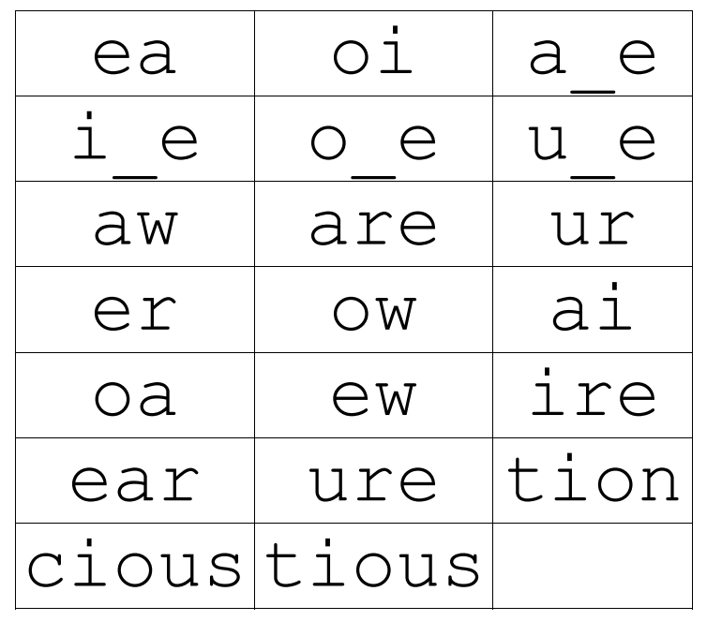
Set 3 Grapheme Rhymes
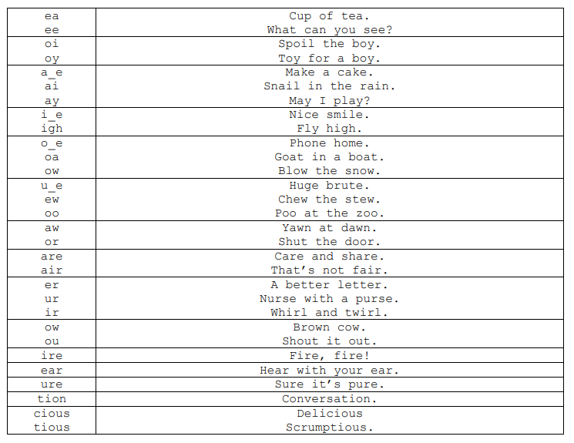
Green words – Yellow group

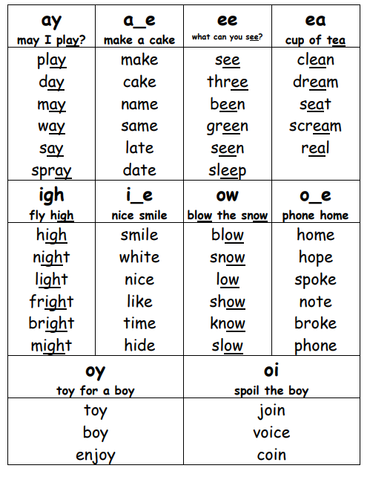
problem | began | wrong | spring | very
thanks | still | much | cannot | tomorrow
sweet | bat | end | sell | himself
kitchen | king | pushed | head | bread
spread | bottom | lived | giving | story
mind | foot | told | check | find
happy | kitten | holiday | being | funny
feeding | knee | body | creep | sheets
shook | seen | silly | tight | send
tonight | week | plant | window | lay
below | narrow | soon | glass | fresh
clock | slept | smooth

Yellow group- Red words
Practise reading these words from sight and practise spelling each word to support independent writing.
one | saw | her | were | their | your
to | go | the | who | tall | by
all | was | some | one | so | they
she | he | be | call | brother | we
they | watch | me | I`m | I`ve | there
said | my | want | watch | some | now
you | are | of | fall | any | where
school | small | do | wall | above | love
by | the | what | want | no | my

