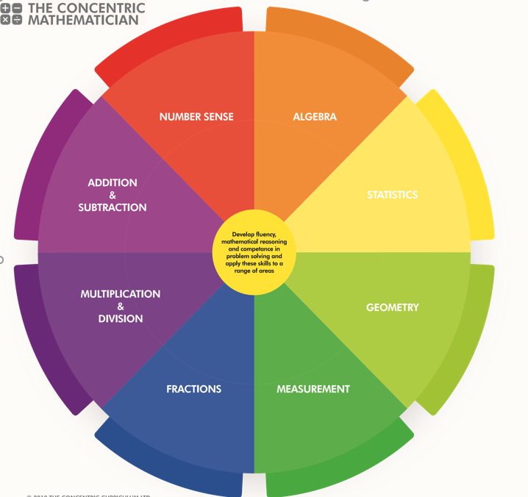
SRPA Mathematician
There are 3 areas underpinning the mathematics curriculum.
Fluency
Pupils develop conceptual understanding and the ability to recall and apply knowledge rapidly and accurately. This is facilitated through varied and frequent practice with increasingly complex problems.
Mathematical reasoning
Pupils learn to follow a line of enquiry and develop an argument, justification or proof using mathematical vocabulary.
Problem solving
Pupils apply their knowledge to a variety of increasingly routine and non-routine problems. They break the problems into a series of simple steps and work systematically to find solutions.

NUMBER SENSE
YEAR 1 PUPIL PASSPORT

I can count to and across 100, forwards and backwards, beginning with 0 or 1, or from any given number....

I can count, read and write numbers to 100 in numerals; count in multiples of 2s, 5s and 10s………………………
Given a number, I can identify 1 more and 1 less.
…………………………………………………………………………….
I can identify and represent numbers using objects and pictorial representations including the number line, and use the language of: equal to, more than, less than (fewer), most, least……………………………………………………………………..
ADDITION AND SUBTRACTION

YEAR 1 PUPIL PASSPORT

I can read and write numbers from 1 to 20 in numerals and words……………………………………………………….....
I can read write and interpret mathematical statements involving addition (+), subtraction (−) and equals (=) signs
…………………………………………………………………............

I can represent and use number bonds and related subtraction facts within 20…………………………………..

I can add and subtract one-digit and two-digit numbers to 20, including 0 solve one-step problems that involve addition and subtraction, using concrete objects and pictorial representations, and missing number problems such as
7 =? – 9………………………………………………………………..

MULTIPLICATION AND DIVISION

YEAR 1 PUPIL PASSPORT

I can solve one-step problems involving multiplication and division, by calculating the answer using concrete objects, pictorial representations and arrays with the support of the teacher……………………………………………………………………

FRACTIONS

YEAR 1 PUPIL PASSPORT

I can recognise, find and name a half as 1 of 2 equal parts of an object, shape or quantity …………………...

I can recognise, find and name a quarter as 1 of 4 equal parts of an object, shape or quantity……………………..

MEASUREMENT

YEAR 1 PUPIL PASSPORT

I can compare, describe and solve practical problems for:
- lengths and heights [for example, long/short, longer shorter, tall/ short, double/half]……………………………………….
- mass/weight [for example, heavy/light, heavier than, lighter than]
- capacity and volume [for example, full/empty, more than, less than, half, half full, quarter]
- time [for example, quicker, slower, earlier, later]

I can measure and begin to record the following: lengths and heights, mass/weight, capacity and volume, time (hours, minutes, seconds)…………………………………………………..

I can recognise and know the value of different denominations of coins and notes …………………………
I can sequence events in chronological order using language [for example, before and after, next, first, today, yesterday, tomorrow, morning, after-noon and evening]
……………………………………………………………………………
I can recognise and use language relating to dates, including days of the week, weeks, months and years …………………………………………………………………………….
I can tell the time to the hour and half past the hour and draw the hands on a clock face to show these times
………………………………………………………………………….…

GEOMETRY

YEAR 1 PUPIL PASSPORT

Shapes
I can recognise and name common 2-D and 3-D shapes,
including:
- 2-D shapes [for example, rectangles (including squares),
circles and triangles]
- 3-D shapes [for example, cuboids (including cubes),
pyramids and spheres]
…………………………………………………………………………….

Position and Direction:
I can describe position, direction and movement, including
whole, half, quarter and three-quarter turns
………………………………………………………………………….…

SRPA TIMES TABLE JOURNEY

Hop on board the times table train as you begin your fun- filled journey to become a Times Table Champion.

Don`t forget to pick up a souvenir at each station and remember… practice makes perfect!

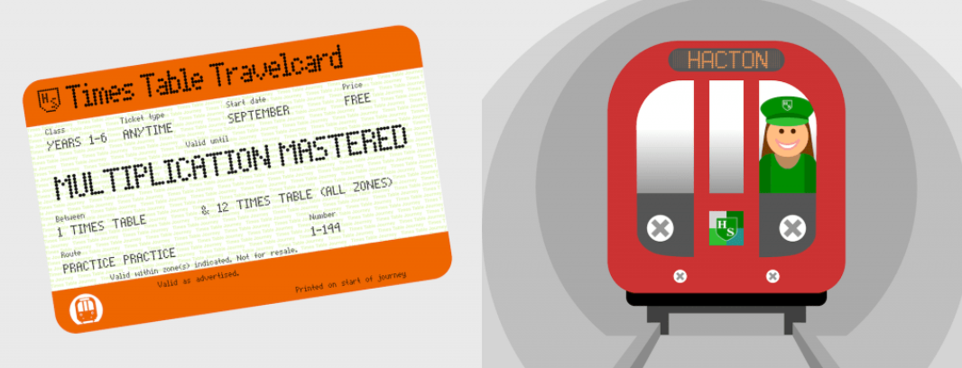
SRPA

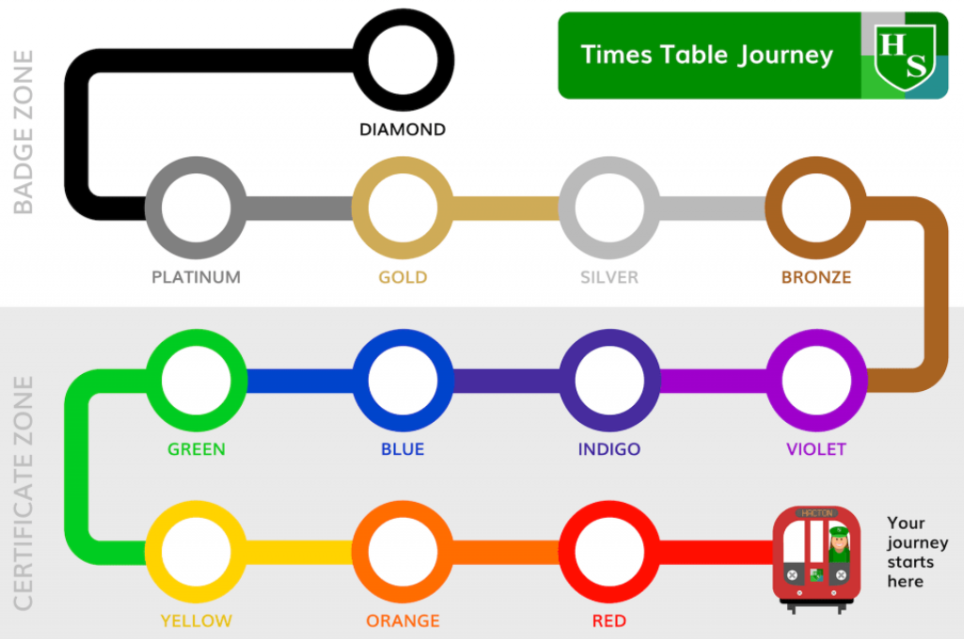
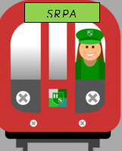
Your journey starts here

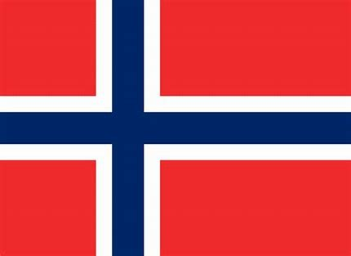

SRPA TIMESTABLE JOURNEY

