SRPA Year 5 Reader

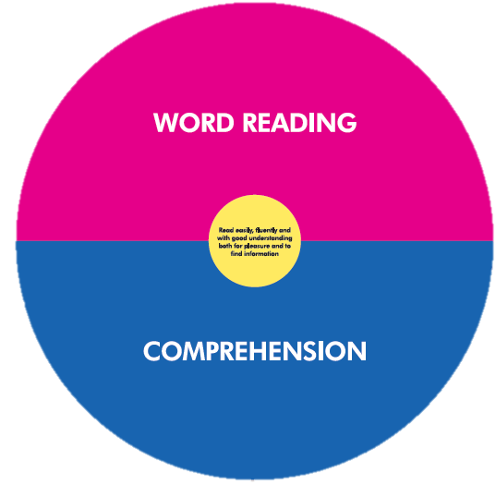

WORD READING
I can apply my growing knowledge of root words, prefixes and suffixes (etymology and morphology) to read aloud and understand new words that I meet

COMPREHENSION
I can continue to read and discuss a wide range of challenging stories, poems, plays, non-fiction and reference books, myths, legends and fairy stories
I can read books that are structured in different ways and read for a range of purposes
I can increase my familiarity with wide range of myths, legends, traditional stories, modern fiction, fiction from literary heritage and books from other cultures
I can recommend books to my peers and give reasons for my choices
I can identify and discuss themes and conventions in and across a wide range of writing
I can make comparisons within and across books
I can prepare poems and plays to read aloud and perform, showing my understanding through intonation, tone, volume to convey so that the meaning is clear to my audience
I can check that the book makes sense to me, discuss my understanding and explore the meaning of words in context
I can ask questions to improve my understanding of a text
I can infer characters’ feelings, thoughts and motives and justify these using evidence
I can summarise the main ideas from more than one paragraph, identifying key details to support the main ideas
I can identify how language, structure and presentation contribute to meaning
I can evaluate how authors’ use of figurative language, considering the impact on the reader
I can distinguish between fact and opinion
I can retrieve, record and present information from non-fiction
I can discuss books (and courteously challenge others’ opinions)
I can explain my understanding through discussions, formal presentations and debates

