Read Write Inc Ditty 1
Speed Sounds
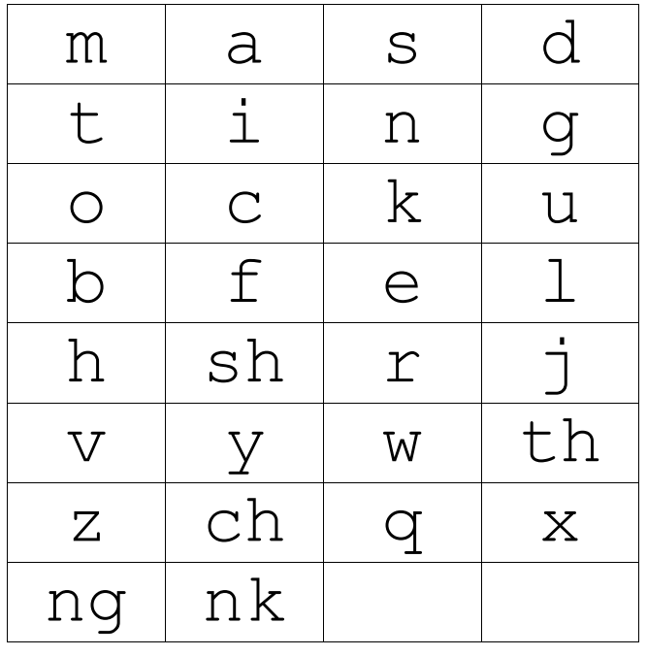

Set 1 Letter Rhymes
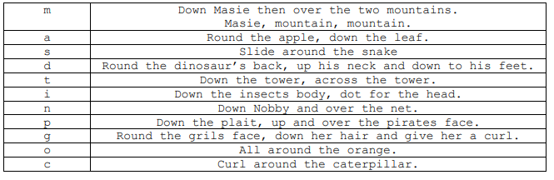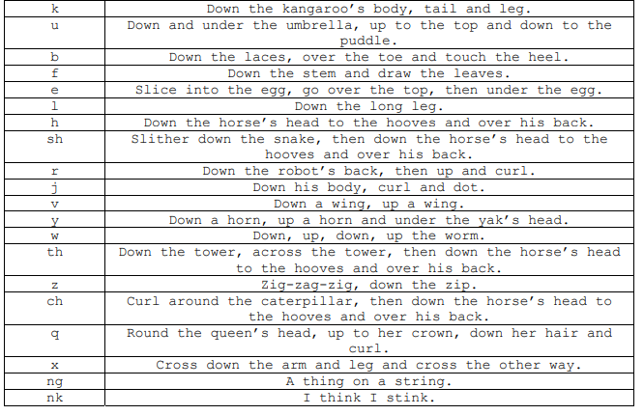

Green words – Ditties 1
cat | sit | tap | fin | fog
tin | map | lip | let | fat
fan | sip | top | tip | ten
man | men | pat | six | tap
lap | zip | put | lot | zap
it | is | in | at | up
on | can | lap | pan | box
fox | lad | top | tin | mix
yes | sat | a | him | big
dog | and

Red Words – Ditty 1
Practise reading these words from sight. We have provided two of each word card so you can play games like ‘memory’ or ‘snap’
I | I
no | no
my | my
the | the
of | of

