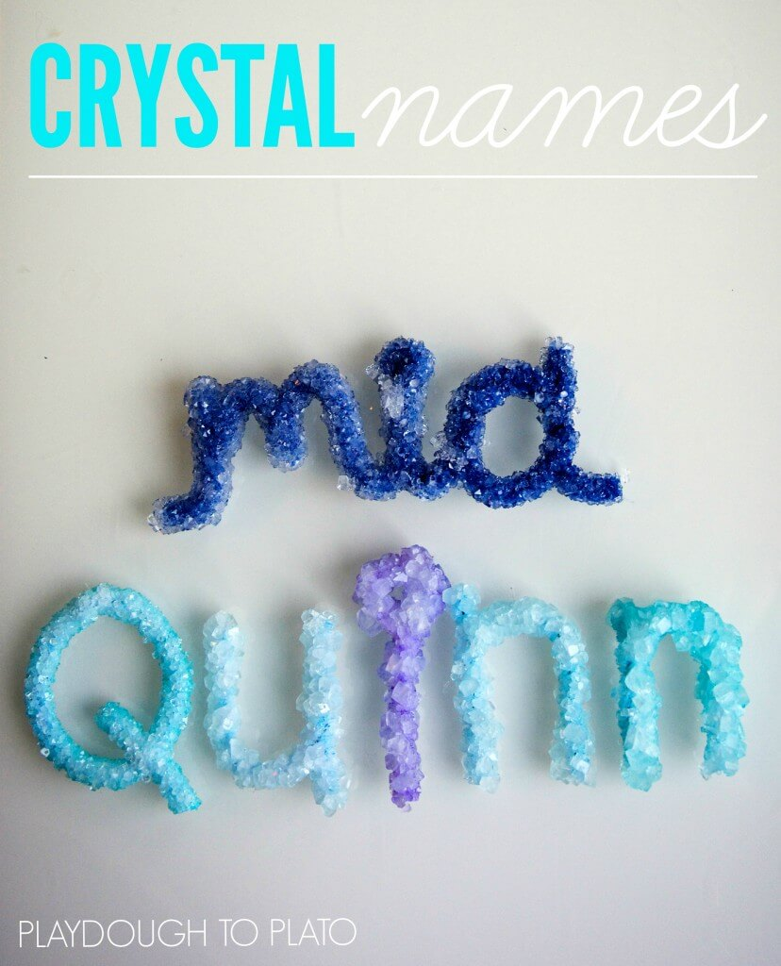

Getting Ready
- Pipe cleaners
- Fishing line {twine or yarn will work too}
- Pencils or wooden skewers
- Scissors
- Glasses or plastic container {one for each color}
- A container large enough to hold your name {if doing your name as a single piece written in cursive}
- Borax
- Food Colouring {optional, if you want coloured letters you can dye the borax solution or use coloured pipe cleaners}
- Liquid measuring cup
- Tablespoon
- Heat Safe Mixing Bowl

Shaping the Names
- 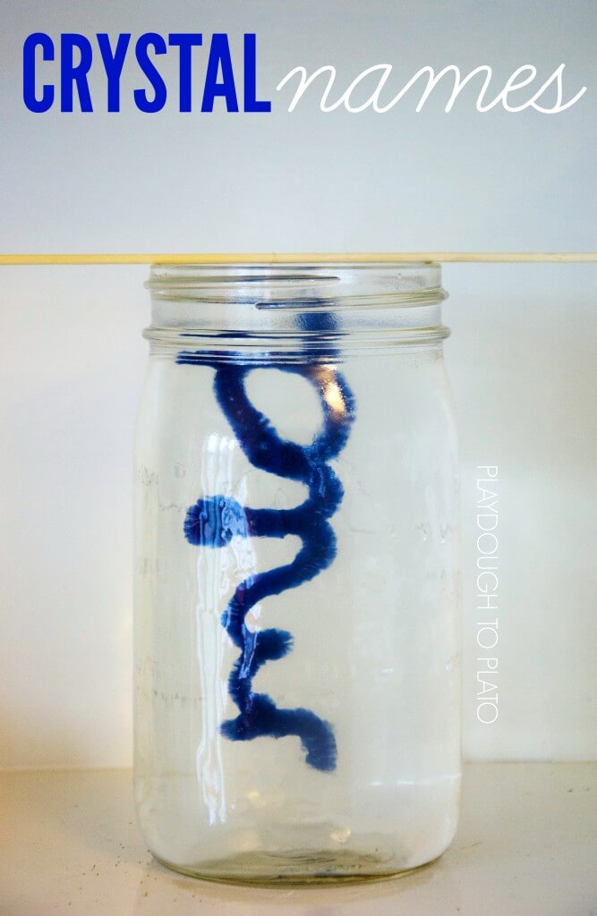
- Take white pipe cleaners and use them to form the letters of your name. (Make sure your letters have enough room to fit in the container without touching any sides.)
- Once formed use fishing line to suspend each letter a few inches from wooden skewers.

Making the Solution
- Heat a large pot of water.
- Decide if you want to make each letter a different colour. If so, set out 5 quart sized plastic containers. Measure out 3 tablespoons of borax per cup of hot water {9 tablespoons per container}.
- Once all the borax is measured, pour 3 cups of almost boiling water into each of the 5 containers.
- Armed with a long wooden spoon, mix each container until the borax dissolves
- Next, add several drops of food colouring to every container and carefully lower each letter into the colour of choice.
- Now, wait!

Final stage
- Once left overnight, remove each letter from their containers and leave to dry on a paper towel
- Once dry, hold up to the light and marvel at the magic crystals that have formed!

The Science Behind It
- When borax is dissolved in water a suspension is created. A suspension is a mixture that has solid particles {the borax} that are large enough for sedimentation {settling out}.
- As the borax begins to settle, it starts to crystalize on all the surfaces it comes in contact with – including the pipe cleaner letters.
- As the borax continues to settle out, it builds crystals on top of other borax crystals creating a thick layer.

