Is your child or the child you are caring for experiencing anxiety, worry or stress?
Are they experiencing psychological or emotional distress?
Do you need to talk to someone who can offer support and advice?
This service is open to Children, Young People, Parents, Carers and Professionals
The Urgent Mental Health Support Telephone line is open now 24 hours a day, 7 days a week on 01752 435122 for advice and support.
Kind regards
CAMHS management

Frederica Kemp
CAMHS Secretary
Based at:-
Plym Bridge House
Office 4, 1st floor
4 William Prance Road
Plymouth, PL6 5ZD
Tel: 01752 431601
Email: Livewell.communitycamhs@nhs.net
Twitter:- https://twitter.com/livewellcamhs

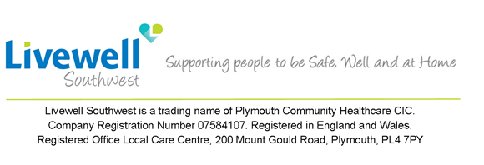
This message may contain confidential information - if you receive it in error, please respect confidentiality and return to sender.

