Read Write Inc Orange Group
Speed Sounds

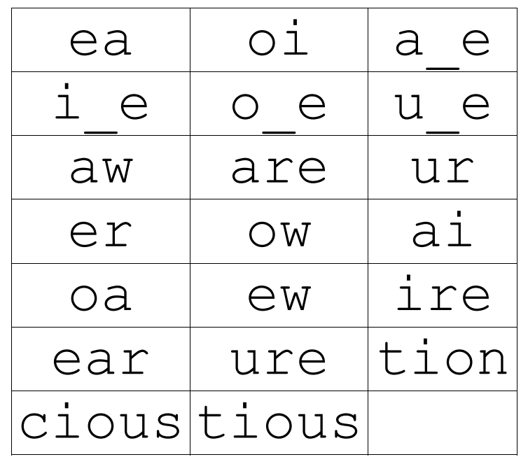
Set 3 Grapheme Rhymes
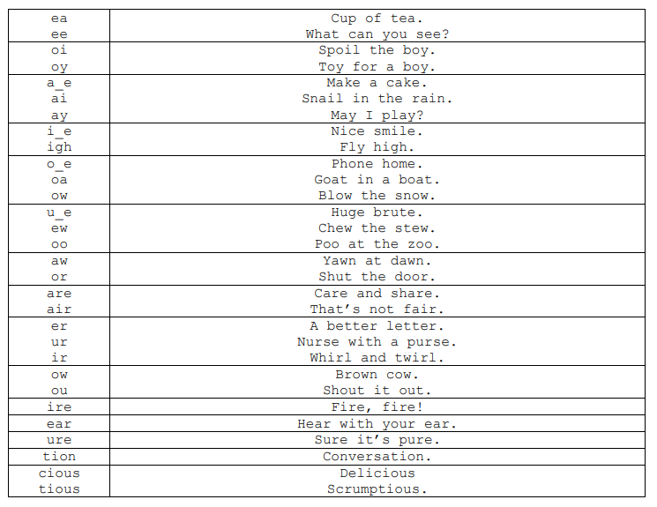

Green words – Orange group
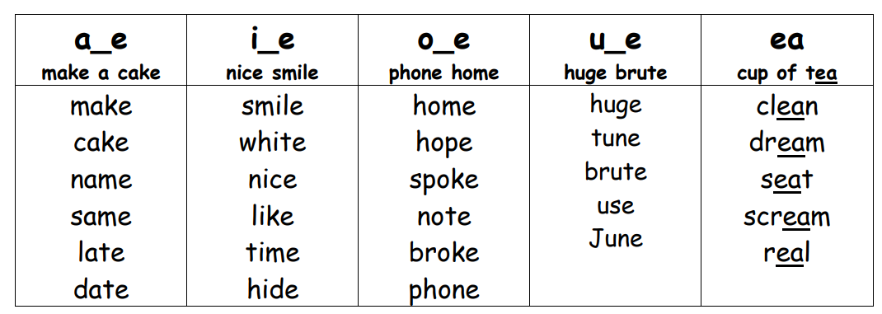

tell | may | think | tree | teeth
fox | frog | need | high | light
fright | yellow | know | show | jump
slow | too | low | cold | little
Sunday | cook | good | feet | took
car | smart | start | far | look
sort | sing | floor | door | more
which | hair | fair | party | girl
shirt | birthday | fight | first | skirt
out | about | see | round | house
lucky | boy | away | join | lunch

Orange group- Red words
Practise reading these words from sight. We have provided two of each word card so you can play games like ‘memory’ or ‘snap’.
what | they | do | what | they | do
said | you | to | said | you | to
the | me | be | the | me | be
want | my | go | want | my | go
he | no | old | he | no | old
my | are | all | my | are | all
he | we | so | he | we | so
was | the | off | was | the | off
of | we | she | of | we | she
her | then | call | her | then | call

