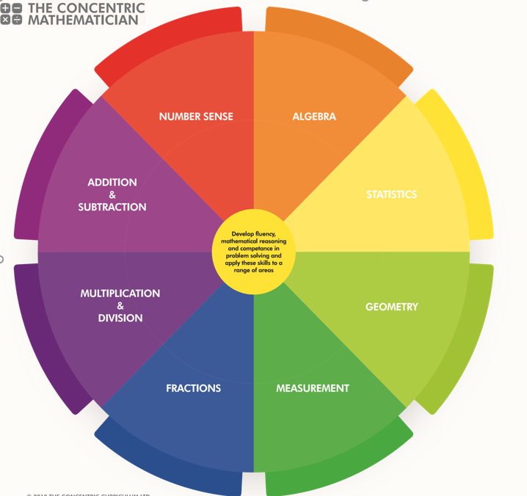
SRPA Mathematician
There are 3 areas underpinning the mathematics curriculum.
Fluency
Pupils develop conceptual understanding and the ability to recall and apply knowledge rapidly and accurately. This is facilitated through varied and frequent practice with increasingly complex problems.
Mathematical reasoning
Pupils learn to follow a line of enquiry and develop an argument, justification or proof using mathematical vocabulary.
Problem solving
Pupils apply their knowledge to a variety of increasingly routine and non-routine problems. They break the problems into a series of simple steps and work systematically to find solutions.

NUMBER SENSE
YEAR 5 PUPIL PASSPORT

I can .read, write, order and compare numbers to at least
1,000,000 and determine the value of each digit
…………………………………….………………………………………

I can count forwards or backwards in steps of powers of 10 for any given number up to 1,000,000………………

I can interpret negative numbers in context, count forwards and backwards with positive and negative whole numbers, including through 0…………………………………………….…

I can round any number up to 1,000,000 to the nearest 10, 100, 1,000, 10,000 and 100,000 ………………………….

I can solve number and practical problems that involve all of the above and with increasingly large positive numbers
……………………………………………….…………………………...

I can read Roman numerals to 1,000 (M) and recognise years written in Roman numerals……………..…………….

ADDITION AND SUBTRACTION

YEAR 5 PUPIL PASSPORT

I can add and subtract whole numbers with more than 4 digits, including using formal written methods (columnar addition and subtraction)……………………….………………

I can add and subtract numbers mentally with increasingly large numbers………………….…………………………………….

I can use rounding to check answers to calculations and determine, in the context of a problem, levels of accuracy solve addition and subtraction multi-step problems in contexts, deciding which operations and methods to use and why
……………………………………………………………………….……

MULTIPLICATION AND DIVISION

YEAR 5 PUPIL PASSPORT

I can identify multiples and factors, including finding all factor pairs of a number, and common factors of 2 numbers
……………………………………………………………………….……

I know and use the vocabulary of prime numbers, prime factors and composite (non-prime) numbers………..……

I can establish whether a number up to 100 is prime and recall prime numbers up to 19………………………………...

I can multiply numbers up to 4 digits by a one- or two-digit number using a formal written method, including long multiplication for two-digit numbers…………………..……

I can multiply and divide numbers mentally, drawing upon known facts…………………………………………………..………

I can divide numbers up to 4 digits by a one-digit number using the formal written method of short division and interpret remainders appropriately for the context………………..…

I can multiply and divide whole numbers and those involving decimals by 10, 100 and 1,000……………….

I can recognise and use square numbers and cube numbers, and the notation for squared (²) and cubed (³)
…………………………………………………………………………....

I can solve problems involving multiplication and division, including using knowledge of factors and multiples, squares and cubes……………………………………………………………..……..

I can solve problems involving addition, subtraction, multiplication and division and a combination of these, including understanding the meaning of the equals sign
………………………………………………………………………….…

I can solve problems involving multiplication and division, including scaling by simple fractions and problems involving simple rates………………………………………………..………….

FRACTIONS

YEAR 5 PUPIL PASSPORT

I can compare and order fractions whose denominators are all multiples of the same number…………………………….

I can identify, name and write equivalent fractions of a given fraction, represented visually, including tenths and hundredths………………………………………………………….…
I can recognise mixed numbers and improper fractions and convert from one form to the other and write mathematical statements > 1 as a mixed number [for example, 2/5 + 4/5 = 6/5 = 1 1/5]……………………………………………………….…

I can add and subtract fractions with the same denominator, and denominators that are multiples of the same number……………………………………….……………………….…

I can multiply proper fractions and mixed numbers by whole numbers, supported by materials and diagrams…….…

I can read and write decimal numbers as fractions [for example, 0.71 = 71/100]………………………………………….

I can recognise and use thousandths and relate them to tenths, hundredths and decimal equivalents……………..

I can round decimals with 2 decimal places to the nearest whole number and to 1 decimal place……………..……….

I can read, write, order and compare numbers with up to 3 decimal places………………………………………………….…….

I can solve problems involving number up to 3 decimal places…………………………………………………………………….

I can recognise the per cent symbol (%) and understand that per cent relates to ‘number of parts per 100’, and write percentages as a fraction with denominator 100, and as a decimal fraction solve problems which require knowing percentage and decimal equivalents of 1/2, 1/4, 1/5, 2/5, 4/5 and those fractions with a denominator of a multiple of 10 or 25…………………………………………………………...……………

MEASUREMENT

YEAR 5 PUPIL PASSPORT

I can convert between different units of metric measure [for example, kilometre and metre; centimetre and metre; centimetre and millimetre; gram and kilogram; litre and millilitre]……

I can understand and use approximate equivalences between metric units and common imperial units such as inches, pounds and pints……………………………………………………………….

I can measure and calculate the perimeter of composite rectilinear shapes in centimetres and metres………………

I can calculate and compare the area of rectangles (including squares), including using standard units, square centimetres (cm²) and square metres (m²), and estimate the area of irregular shapes………………………………………….…….

I can estimate volume [for example, using 1 cm³ blocks to build cuboids (including cubes)] and capacity [for example, using water]……………………………………………………….…

I can solve problems involving converting between units of time use all four operations to solve problems involving measure
[for example, length, mass, volume, money] using decimal notation, including scaling……………………………..………

GEOMETRY

YEAR 5 PUPIL PASSPORT

Shapes
I can identify 3-D shapes, including cubes and other cuboids, from 2-D representations ………………………….

I know angles are measured in degrees: estimate and compare acute, obtuse and reflex angles……………….…

I can draw given angles, and measure them in degrees (°)
…………………………………………………………………………….

I can identify:
- angles at a point and 1 whole turn (total 360°)
- angles at a point on a straight line and half a turn
(total 180°)
- other multiples of 90°
…………………………………………………………………….………

I can use the properties of rectangles to deduce related facts and find missing lengths and angles……………….....…

I can distinguish between regular and irregular polygons based on reasoning about equal sides and angles
…………………………………………………………………………….

STATISTICS

YEAR 5 PUPIL PASSPORT

I can solve comparison, sum and difference problems using information presented in a line graph………………………

I can complete, read and interpret information in tables, including timetables………………………………………………..
ALGEBRA

YEAR 5 PUPIL PASSPORT

I can solve addition and subtraction problems involving missing numbers…………………………………………………...

SRPA TIMES TABLE JOURNEY

Hop on board the times table train as you begin your fun- filled journey to become a Times Table Champion.

Don`t forget to pick up a souvenir at each station and remember… practice makes perfect!

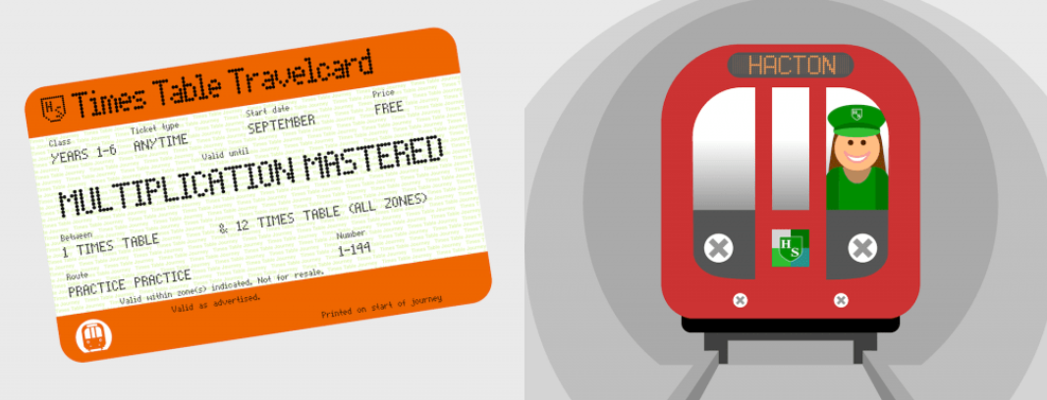
SRPA

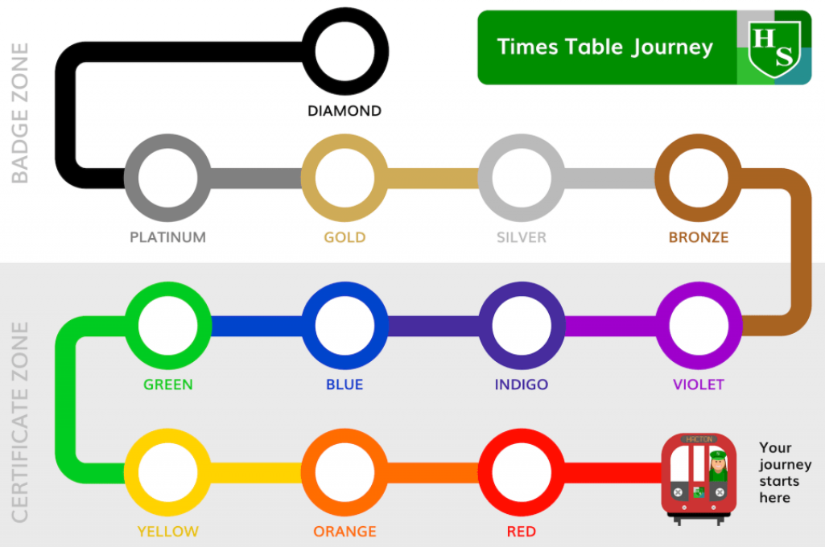
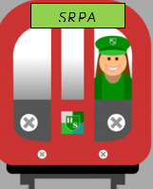
Your journey starts here

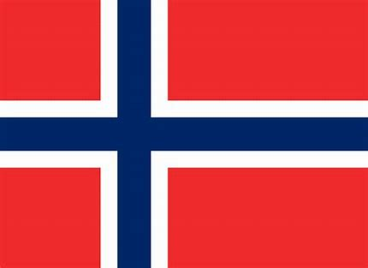

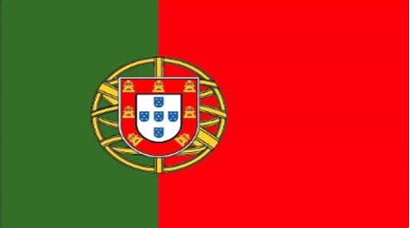

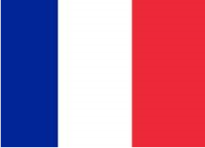

SRPA TIMESTABLE JOURNEY

