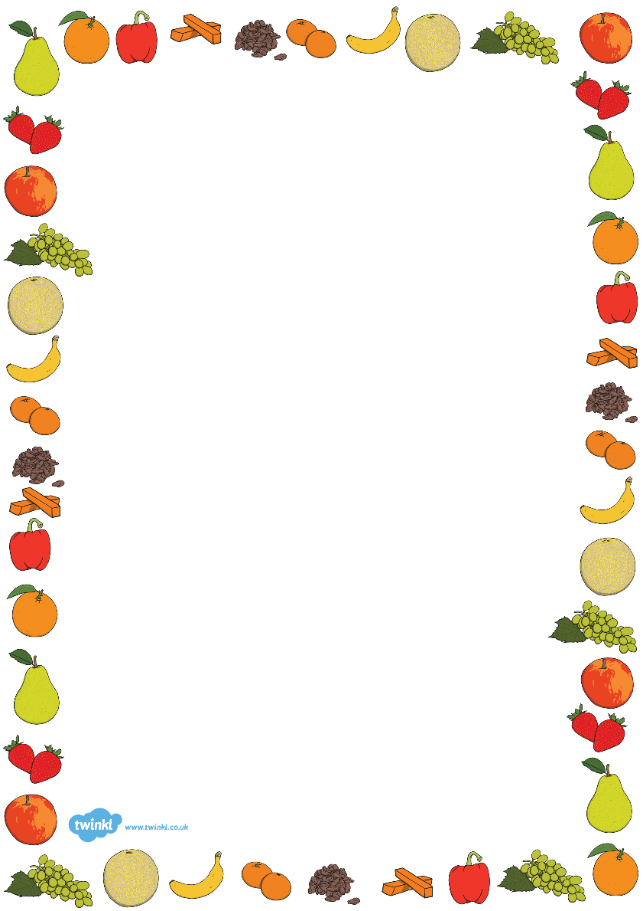

Snacks 2 Go

Popcorn

Mini Cheddars

Babybel

Cheese string

Yoghurt Pouch

Fruit and Carrot Juice

Fruit Shots

Fruit Flakes

Fruit Bars

Fruit Biscuit Slices

Pain au Chocolat

Rice Cakes

Muesli Bars