**Assessment**

The children will be able to compare their characteristics with those of family members and conclude whether they are due to nature or nurture. They will take accurate measurements to evaluate the Vitruvian man and present their findings to an audience.

**Local Science links**

Considering local community and differences in populations

**Engage – John Doe who has no identity**

**Innovate – Crime scene**

**Cross-curricular links**

**Reading** – Fantastically Great Women Who Changed the World

*English – The Switch*

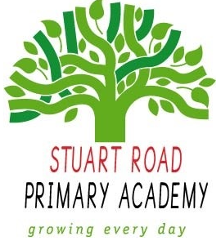

**Stuart Road Academy Science Curriculum**

**Termly Overview**

**Year 6 Term 1 – ID**

**Unit Overview**

*This unit will develop children’s knowledge of classification and inheritance. Children explore human identity, genetic characteristics, family traits and their own values and beliefs.*

**Knowledge, Skills and Concepts**

* recognise that living things produce offspring of the same kind, but normally offspring vary and are not identical to their parents – nature vs nurture family resemblance lesson, comparing fingerprints, height
* taking measurements, using a range of scientific equipment, with increasing accuracy and precision, taking repeat readings when appropriate
* recording data and results of increasing complexity using scientific diagrams and labels, classification keys, tables, scatter graphs, bar and line graphs – measuring body parts to work out ratios
* reporting and presenting findings from enquiries, including conclusions, causal relationships and explanations of and a degree of trust in results, in oral and written forms such as displays and other presentations
* identifying scientific evidence that has been used to support or refute ideas or arguments – Vitruvian man