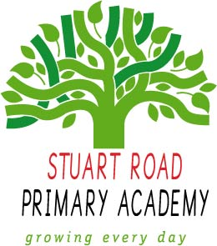
Stuart Road Primary Academy
Home Learning
Year 6 Spring 2020
Theme: Stone Age to Iron Age
To get the most out of your home learning you must:
Complete the ‘daily tasks’ every day.
Select another task of your choice to complete each week.
We look forward to sharing your completed work in school.
Creative Writing
- Write a report about an animal that would have lived in Stone Age.
- Create your own fact book about aspects of Iron Age e.g. homes, food, farming.
- Create a lapbook with differenes between Stone Age, Bronze Age and Iron Age.
- Create an information leaflet about the Stone, Iron, or Bronze Age.
- Create a comic strip of the typical day in the Stone Age.
- Write a diary entry as if you were a hunter/gatherer.

Theme
- Find out about how a fosil is made. Draw a picture and create a poster about it.
- Design your own fossil
- Make up your own story and tell it through cave pictures
- Make a model of a round house.
- Make a model of a Iron Age shield
- Come up with yor own learning project related to our topic.
- Create an outfit for a Stone Age Man/ Woman and think about and label the materials.
- Create a quiz on the Stone, Bronze or Iron Age - Test your parents!
- Draw or paint yourself as an Iron Age man / woman.
- Create cave paintings.

Maths
-Practise your timestables via TTRockstarts
-Practice number fluency via Numbots
Archaelogists have found markings in caves and they think it might be Stone Age counting. Can you come up with your own counting system? You might want to choose symbols to mean certain amounts. Will you choose to count in sets of 10or will your counting system work in another way?

Daily tasks
- Read your reading book.
- Practise your handwriting.
- Practise your spellings.

