Read Write Inc Purple Group
Speed Sounds
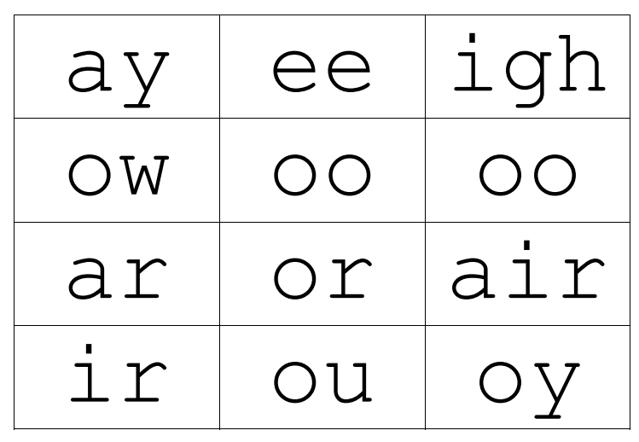

Set 2 Grapheme Rhymes
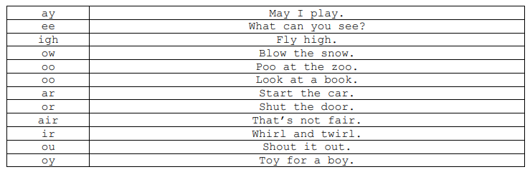

Green words – Purple group
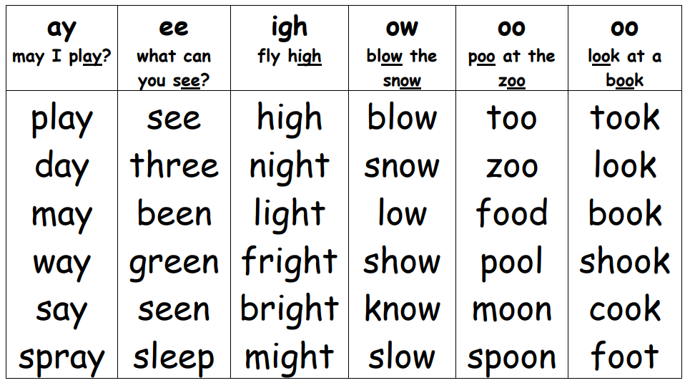

full | has | lost | left | help
ran | let | wet | at | shop
stop | chips | swim | run | dad
hid | sang | job | thing | hat
next | bug | log | sand | back
stick | cross | mum | mat | mess
did

Purple group- Red words
Practise reading these words from sight. We have provided two of each word card so you can play games like ‘memory’ or ‘snap’.
the | your | I | the | your | I
of | my | be | of | my | be
no | are | do | no | are | do
we | all | they | we | all | they
for | said | he | for | said | he
some | to | is | some | to | is
in | go | me | in | go | me

