Hello! My name is Mrs Haddy. I look after the youngest children at Stuart Road and High Street. I will come and visit you when you start school. This is what I look like….

I like football and I watch Plymouth Argyle with my family (I have a husband and 2 sons called Oliver and Daniel).

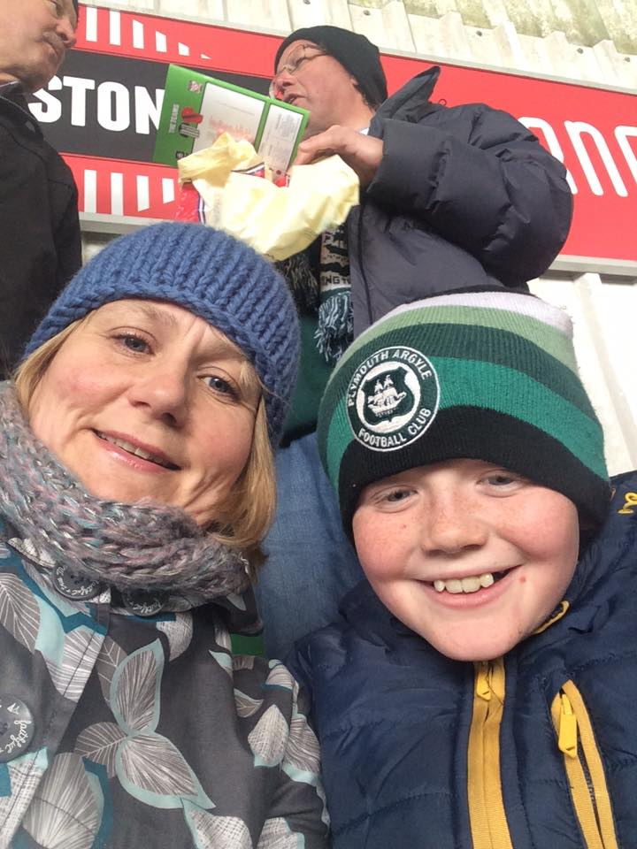

I like to read a lot and one of my favourite places to go is Waterstones in Plymouth. I also like gardening – here is a photo of my garden….

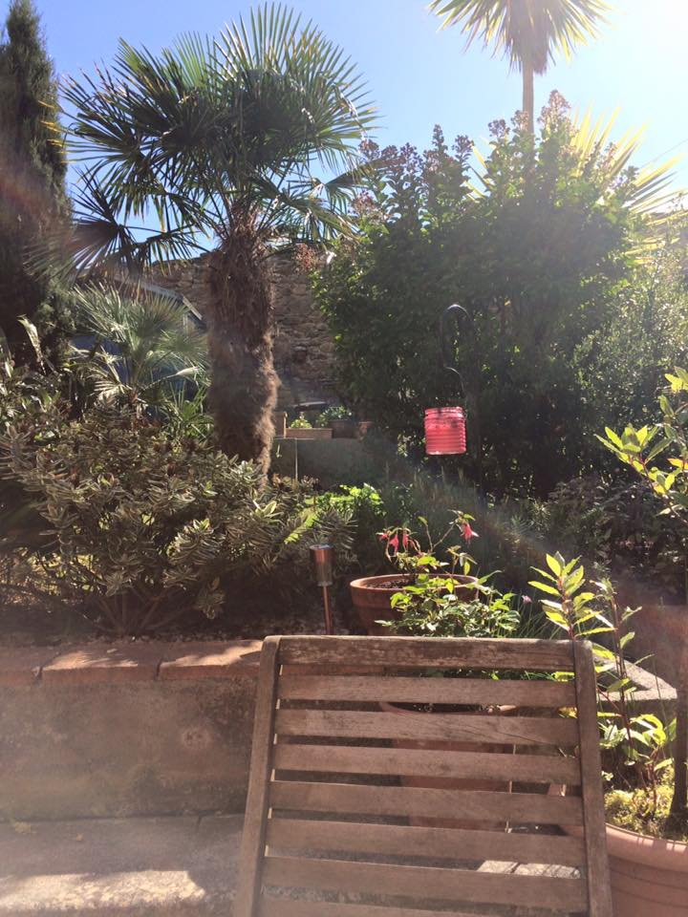

I love to sit in my garden and read!

I also like singing and I sing in a choir. This means that I sing with lots of other people.

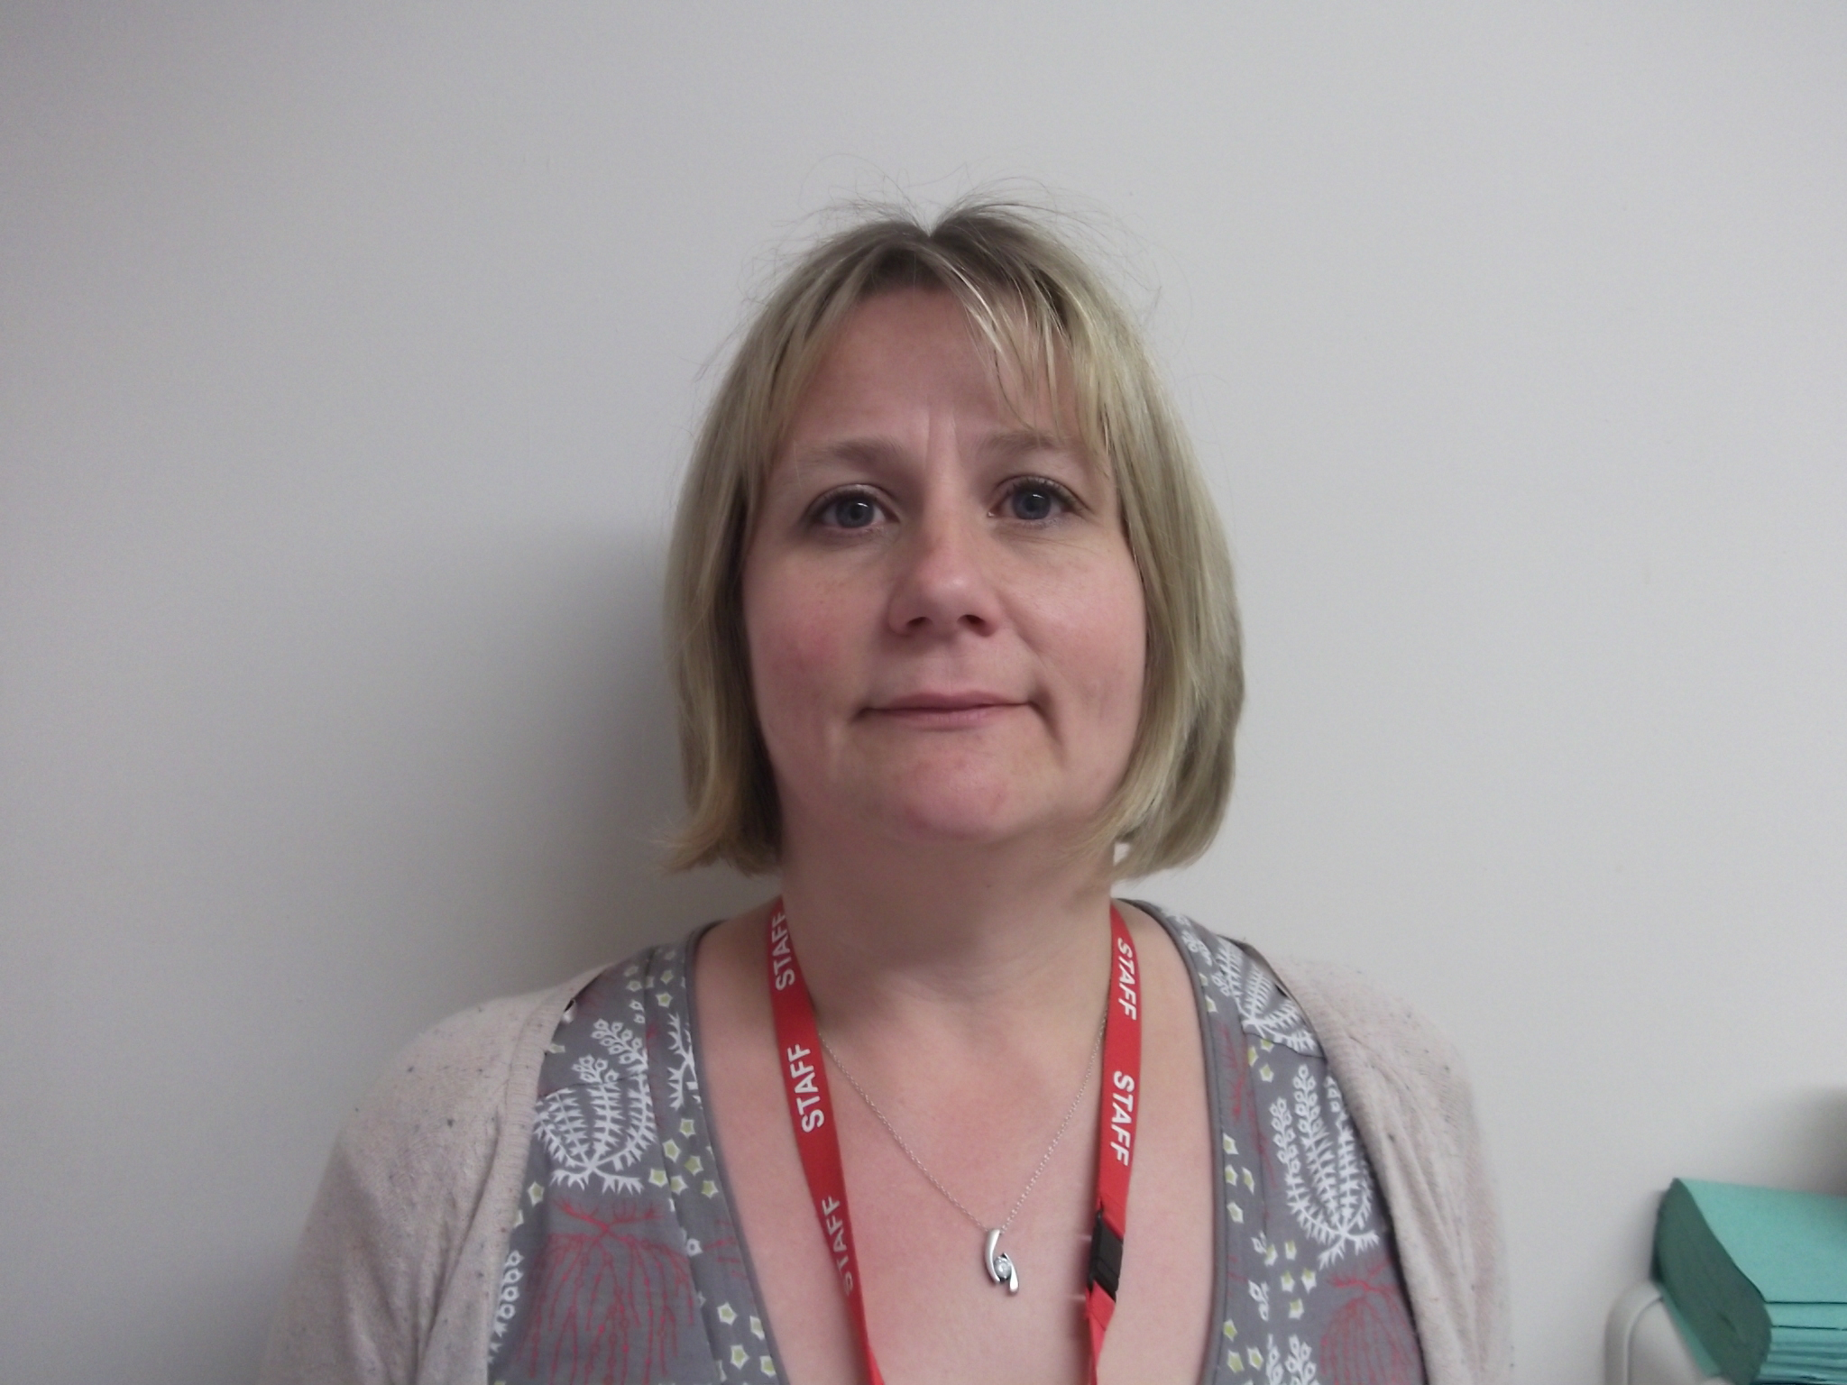

I have 2 cats who are called Freddie and Florrie. They like to sleep a lot!

